|  |
| --- |
| **MINI PROJECT REPORT**  **ON**  **TEMPLE PASS SYSTEM**  as a part of  ***Project Based Learning***  Submitted by  **Mr. Pawar Chetan (A54)**  **Mr. Pardeshi Mohit (A50)**  **Mr. Mankar Yogesh (A46)**  Guided by  **Prof. M. E. Maniyar**  **Master of Computer Applications**  (Under Faculty of Engineering)    **Department of MCA**  K. K. Wagh Institute of Engineering Education & Research,  Hirabai Haridas Vidyanagari, Amrutdham, Panchavati,  Nashik – 422 003 |
|  |

|  |
| --- |
| **K. K. Wagh Institute of engineering education & research**  **NasHik – 422003**  ***CERTIFICATE***  This is to certify that  **Mr. Pawar Chetan (A54)**  **Mr. Pardeshi Mohit (A50)**  **Mr. Mankar Yogesh (A46)**  has successfully completed the Mini Project on  **TEMPLE PASS SYSTEM**  as a part of  ***Project Based Learning***  during academic year 2021 – 22  **Prof. M. E. Maniyar Prof. V. C. Bagal Dr. K. N. Nandurkar**  Project Guide I/c Head, Principal  Dept. of MCA |
| **Abstract**  Temple Pass System is web-based application which helps temple administration to store the data of users (devotees), manage devotee’s donation and manage Darshan Pass booking. The system is also intended to provide better services to users (devotees) provide meaningful, consistent, and timely data and information and finally promotes efficiency by converting paper processes to electronic form. The system was developed using basic technologies such as MySQL database and PHP. The system is free of errors and very efficient and less time consuming due to the care taken to develop it. All the phases of software development cycle are employed and it is worthwhile to state that the system is user friendly and strong. Provision is made for future development in the system. |
| **List of Figures**   |  |  |  | | --- | --- | --- | | **Figure No.** | **Caption** | **Page No.** | | 1 | Use Case Diagrams: User | 9 | | 2 | Use Case Diagrams: Admin | 10 | | 3 | Entity-Relationship Diagram Shapes | 11 | | 4 | Entity-Relationship Diagram | 12 | | 5 | Symbols for Data Flow Diagrams | 14 | | 6 | Zero Level DFD | 15 | | 7 | First Level DFD | 16 | | 8 | Second Level DFD | 17 | | 9 | Class Diagram | 23 | |
| **List of Tables**   |  |  |  | | --- | --- | --- | | **Table No.** | **Title** | **Page No.** | | 1 | tbladmin table Structure | 19 | | 2 | tblbookdarshan table Structure | 20 | | 3 | tbldonation table Structure | 20 | | 4 | tblfestivals table Structure | 21 | | 5 | tblpage table Structure | 21 | | 6 | tbltemple table Structure | 21 | | 7 | tbluser table Structure | 22 | | 8 | Test Cases | 26 | |
| **Abbreviations**   * TPS: Temple Pass System * HTML: HypterText Markup Language * UML: Unified Modelling Language Diagrams * RAM: Random Access Memory * IDE: Integrated Development Environment * DFD: Data Flow Diagram |

**Table of Contents**

|  |  |  |
| --- | --- | --- |
| **Sr. No.** | **Particulars** | **Pg. No.** |
| 1. | Abstract | I |
| 2. | List of Figures | II |
| 3. | List of Tables | III |
| 4. | Abbreviations | IV |
| 5. | Introduction | 1 |
| 6. | Feasibility Study | 3 |
| 7. | Scope of the Project | 4 |
| 8. | System Requirements | 6 |
| 9. | System Design | 7 |
| 10. | Database Design | 19 |
| 11. | System Testing | 24 |
| 12. | Test cases | 26 |
| 13. | Output Screen Shots of project | 28 |
| 14. | Conclusion | 61 |
| 15. | Bibliography | 62 |
| 16. | Acknowledgement | 63 |

**Introduction**

**Temple Pass System** is software which is helpful for temple administrator and devotees. In the current system all the activities are done manually. It is very time consuming and costly. Our Temple Pass System deals with the various activities related to the temple and devotees.

The two main users involved in this system are

1. Users (i.e., Devotees)
2. Admin

In the Software users(devotees) can register themselves by the authentication code i.e email id or mobile number and password with help of email id or mobile number devotees can login his/her account and view all the information which is announced by admin.

**Purpose of the System:**

The objective of **Temple Pass System** is to allow the administrator of any temple to edit and find out the personal details of devotees and allows the devotees to keep the data up to date, donate the amount and make booking of the darshan online. It’ll also facilitate keeping all the records of devotee, such as their name, mailing address, and phone number. So all the information about a devotees will be available in a few seconds. Administration makes the report of donation collection in particular period in a particular temple.

Overall, it’ll make Temple Pass System an easier job for the administrator and the devotees.

**Advantages:**

* It helps the temple administrator to handle and manage devotee’s records.
* It helps temple administrator to generate report.
* It brings transparency and efficiency in the working of Temple Pass System.
* Simple user interface to reduce operation time.
* Reduce the data entries lead to eliminate chances of error and reduce operator efforts.
* The system handles multiple temple organization.

**Applications:**

The website **Temple Pass System** is aimed towards recording a considerable number of devotee records, darshan booking and donation which is all handle by single administration. Website should be user-friendly, ‘quick to learn’ and reliable website for the above purpose. **Temple Pass System** is intended to be a stand-alone product andshould not depend on the availability of other website. The system will also have an administrator who has full-fledged rights with regards to performing all actions related to control and management of the website.

**Feasibility Study**

Whenever we design a new system, normally the management will ask for a feasibility report of the new system. The management wants to know the technicalities and cost involved in creation of new system.

- Technical feasibility

- Economic feasibility

- Physical feasibility

**Technical feasibility:**

Technical feasibility involves study to establish the technical capability of the system being created to accomplish all requirements to the user. The system should be capable of handling the proposed volume of data and provide users and operating environment to increase their efficiency.

For example, system should be capable of handling the proposed volume of data and provide users.

**Economic feasibility:**

Economic feasibility involves study to establish the cost benefit analysis. Money spent on the system must be recorded in the form of benefit from the system. The benefits are of two types:

**Tangible benefits:**

* + Saving man labor to do tedious tasks saves time.

**Intangible benefits:**

* + Improves the quality of temple organization.

**Physical feasibility:**

It involves study to establish the time responses of the new system being created. For e.g., if the new system takes more than one day to prepare crucial finance statement for the management, wherever it was required in an hour, the system fails to provide the same.

It should be clearly established that the new system requirements in the form of time responses would be completely met with. It may call for increase in cost. If the required cost is sacrificed then the purpose of the new system may not be achieved even if it was found to be technically feasible.

**Scope of the Project**

Temple Pass System is web-based application which help temple administration to store the data of users (devotees), manage devotee’s donation and manage darshan booking.

Temple Pass System Software is web-based application which automate the charitable trusts that run and maintain temple organizations. The challenges addressed include integrating modules to manage donations, devotee’s database and festivals. The software is built to be an easy to use interface and the navigation is simple. We have also integrated modules to generate relevant reports.

All possible features such as verification, validation, security, user friendliness etc. have been considered.

The different types of modules present in this project are

1. Admin
2. Users (Devotees)

**Admin:**

1. **Dashboard**: In this section, admin can see all detail in brief like Total new darshan booking, accepted darshan booking, rejected darshan booking, total donation, total temple and total festivals.
2. **Temple**: In this section, admin can manage temple (Add/Update/Delete).
3. **Festivals**: In this section, admin can manage the festivals (Add/Update/Delete).
4. **Darshan Booking:** In this section, the admin can manage darshan booking and update the status of booking.
5. **View Donation:** In this section, the admin can view the donation detail and print the receipt.
6. **Reports:** In this section admin, can generate the following reports in a particular period

* Darshan booking: In this section, admin can generate the between dates reports of darshan booking
* Reports of Donation: In this section, admin can generate the between dates reports of donation.
* Collected Donation: In this section, admin can generate the report of amount which is collected in a particular temple.
* Registered devotees: In this section, admin can generate the between dates reports of devotees who registered themselves with temple organization.

1. **Pages:** In this section admin, can manage about us and contact us page of administration
2. **Search:** In this section admin, can search following details.

* Darshan booking: In this section, admin can search booking detail by booking number.
* Donation Receipt: In this section, admin can search booking detail by donation number(receipt number).
* **Reg Devotees:** In this section, admin can search booking detail by mobile number.

1. **Registers Devotees: In this section, admin can view the detail of registered devotees.**

Admin can also update his profile, change the password and recover the password.

**User (Devotees):**

1. **Home**: It is welcome page for devotees.
2. **Donation History**: User can view donation history.
3. **Darshan History**: User can view darshan history and darshan booking status.
4. **Profile**: User can update his/her profile.
5. **Change Password**: User can change the password of their account.
6. **Logout**: User can logout from website.
7. **Our Festivals**: User can view all the festivals which is celebrated in the temples.
8. **Temples**: User can view the temple detail, send the donation and book darshan.
9. **About:** User can view about us page.
10. **Contact:** User can view contact us page.

**User (Non-Register Devotees):**

1. **Home**: It is welcome page for user.
2. **About**: User can view about us page.
3. **Contact:** User can view contact us page.
4. **Our Festivals**: User can view all the festivals which is celebrated in the temples.
5. **Temples**: User can view the temple detail.

**Software & Hardware Requirements**

**Hardware requirements:**

* Any processor after Pentium 4.
* Any version of Windows XP or later.
* Processor speed: 2.0 GHz
* RAM : 1GB
* Hard disk: 40GB to 80 GB

**Software requirements:**

* Database : MySQL
* Server : Apache
* Frontend : HTML
* Scripting Language : JavaScript
* IDE : Eclipse for PHP /Sublime
* Technology : PHP
* Any Version of browser after Mozilla Firefox 4.0, Internet Explorer 6.0, chrome

**System Design**

Design is the first step in the development phase for any techniques and principles for the purpose of defining a device, a process or system in sufficient detail to permit its physical realization.

Once the software requirements have been analyzed and specified the software design involves three technical activities - design, coding, implementation and testing that are required to build and verify the software.

The design activities are of main importance in this phase, because in this activity, decisions ultimately affecting the success of the software implementation and its ease of maintenance are made. These decisions have the final bearing upon reliability and maintainability of the system. Design is the only way to accurately translate the customer’s requirements into finished software or a system.

Design is the place where quality is fostered in development. Software design is a process through which requirements are translated into a representation of software. Software design is conducted in two steps. Preliminary design is concerned with the transformation of requirements into data

**Unified Modelling Language Diagrams (UML):**

* + The unified modelling language allows the software engineer to express an analysis model using the modelling notation that is governed by a set of syntactic semantic and pragmatic rules.
  + A UML system is represented using five different views that describe the system from distinctly different perspective. Each view is defined by a set of diagram, which is as follows.

**User Model View**

* + 1. This view represents the system from the user’s perspective.
    2. The analysis representation describes a usage scenario from the end-users perspective**.**

**Structural model view**

* In this model the data and functionality are arrived from inside the system.
* This model view models the static structures.

**Behavioural Model View**

* It represents the dynamic of behavioural as parts of the system, depicting the interactions of collection between various structural elements described in the user model and structural model view.

**Implementation Model View**

* In this the structural and behavioural as parts of the system are represented as they are to be built.

**Environmental Model View**

In this the structural and behavioural aspects of the environment in which the system is to be implemented are represented.

UML is specifically constructed through two different domains they are

* UML Analysis modelling, which focuses on the user model and structural model views of the system?
* UML design modelling, which focuses on the behavioural modelling, implementation modelling and environmental model views**.**

**Fig. 1 Use Case Diagrams: User**

### USER

### Fig. 2 Use Case Diagrams: Admin

**ADMIN**

#### Fig. 3 Entity-Relationship Diagram Shapes

E-R (Entity-Relationship) Diagram is used to represents the relationship between entities in the table.

## The symbols used in E-R diagrams are:

SYMBOL PURPOSE

Represents Entity sets.

Represent attributes.

Represent Relationship Sets.

Line represents flow

Structured analysis is a set of tools and techniques that the analyst.

To develop a new kind of a system:

The traditional approach focuses on the cost benefit and feasibility analysis, Project management, and hardware and software selection a personal consideration.

#### C:\Users\pande\Downloads\OTMSERdia.drawio.pngFig. 4 Entity-Relationship Diagram

**Data Flow Diagram**

A Data Flow Diagram (DFD) is a traditional visual representation of the information flows within a system. A neat and clear DFD can depict the right amount of the system requirement graphically. It can be manual, automated, or a combination of both.

It shows how data enters and leaves the system, what changes the information, and where data is stored.

The objective of a DFD is to show the scope and boundaries of a system as a whole. It may be used as a communication tool between a system analyst and any person who plays a part in the order that acts as a starting point for redesigning a system. The DFD is also called as a data flow graph or bubble chart.

**The following observations about DFDs are essential:**

1. All names should be unique. This makes it easier to refer to elements in the DFD.
2. Remember that DFD is not a flow chart. Arrows is a flow chart that represents the order of events; arrows in DFD represents flowing data. A DFD does not involve any order of events.
3. Suppress logical decisions. If we ever have the urge to draw a diamond-shaped box in a DFD, suppress that urge! A diamond-shaped box is used in flow charts to represents decision points with multiple exists paths of which the only one is taken. This implies an ordering of events, which makes no sense in a DFD.
4. Do not become bogged down with details. Defer error conditions and error handling until the end of the analysis.

Standard symbols for DFDs are derived from the electric circuit diagram analysis and are shown in fig:

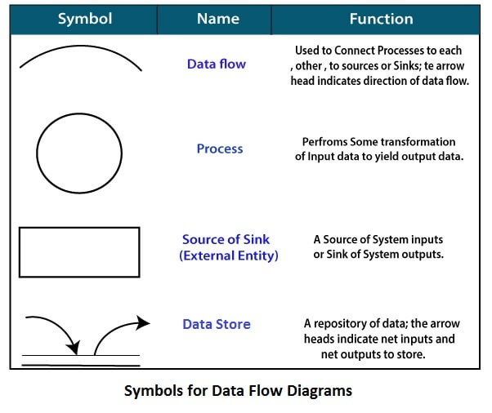

***Fig. 5 Symbols for Data Flow Diagrams***

**Circle:** A circle (bubble) shows a process that transforms data inputs into data outputs.

**Data Flow:** A curved line shows the flow of data into or out of a process or data store.

**Data Store:** A set of parallel lines shows a place for the collection of data items. A data store indicates that the data is stored which can be used at a later stage or by the other processes in a different order. The data store can have an element or group of elements.

**Source or Sink:** Source or Sink is an external entity and acts as a source of system inputs or sink of system outputs.

**Fig. 6 Zero Level DFD**

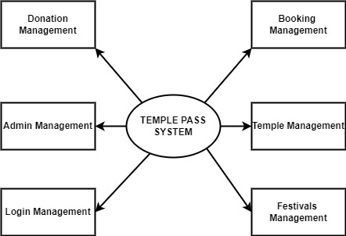

**Fig. 7 First Level DFD**

**Login Management**

**Report of Darshan Booking**

**Festival Management**

**Report of donation receipt**

**Temple Management**

**Report of donation collected**

**User Management**

**Search Donation Receipt**

**Booking Management**

**Search Darshan Booking**

**Donation Management**

**Search Reg Users (devotees)**

**Admin Management**

**Check User (devotees) Login**

**Fig. 8 Second Level DFD**

**Admin**

**Manage Temple**

**Manage Festivals**

**Manage Darshan Booking**

**View Donation**

**Manage Pages**

**Generate Booking Report**

**Generate Donation Report**

**Generate Donation Report**

**Generate Reg Users Report**

**View Reg Users**

**Change Profile**

**Change Password**

**Search Booking, Reg Users and Receipt**

**Users (devotees)**

**View Darshan Booking**

**View Donation Receipt**

**Send Booking Request**

**Donate Money**

**View Temple Festivals**

**View Temple**

**Change Password**

**Update Profile**

**Database Design**

The data in the system has to be stored and retrieved from database. Designing the database is part of system design. Data elements and data structures to be stored have been identified at analysis stage. They are structured and put together to design the data storage and retrieval system.

A database is a collection of interrelated data stored with minimum redundancy to serve many users quickly and efficiently. The general objective is to make database access easy, quick, inexpensive and flexible for the user. Relationships are established between the data items and unnecessary data items are removed. Normalization is done to get an internal consistency of data and to have minimum redundancy and maximum stability. This ensures minimizing data storage required, minimizing chances of data inconsistencies and optimizing for updates. The MySql database has been chosen for developing the relevant databases.

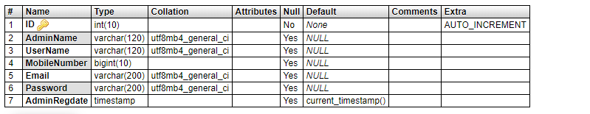**Temple Pass System (TPS) contains 7 MySQL tables:**

**Table 1: tbladmin table Structure:** This table stores the admin login and personal Details.

**Table 2: tblbookdarshan table Structure:** This table stores the darshan booking details of devotees.

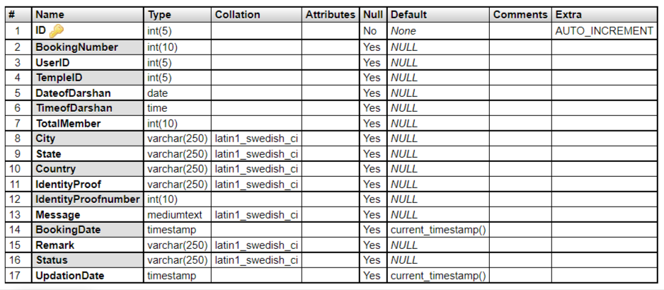

**Table 3: tbldonation table Structure:** This table stores the donation detail.

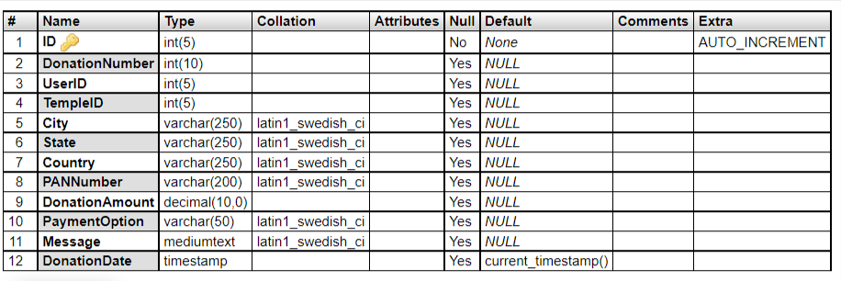

**Table 4: tblfestivals table Structure:** This table store the festivals details which is celebrated in temple.

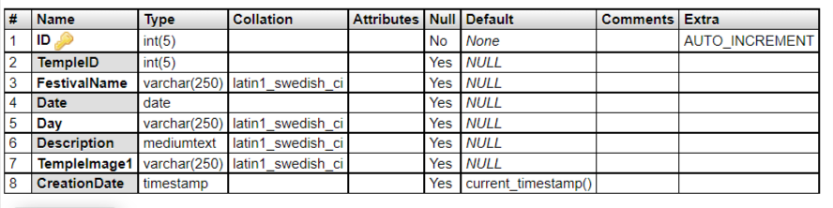

**Table 5: tblpage table Structure:** This table stores the details of about us and contacts us pages.

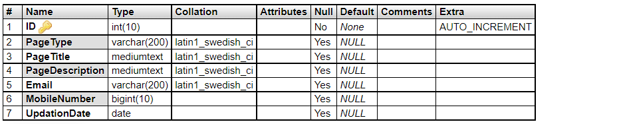

**Table 6: tbltemple table Structure:** This table stores the details of temple.

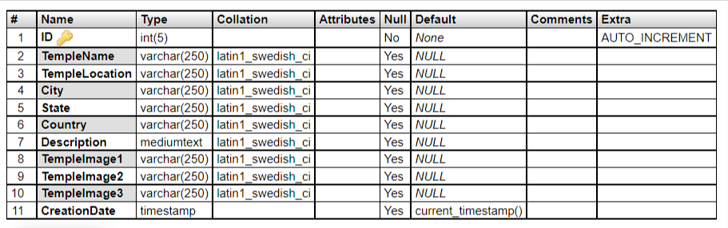

**Table 7: tbluser table Structure:** This table store the details of users(devotees).

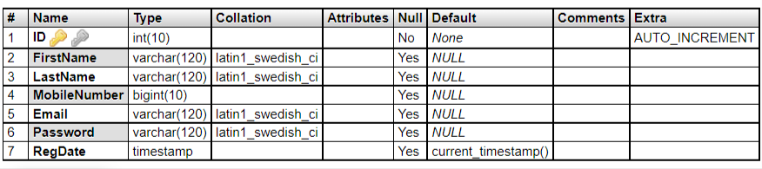

**Class Diagram:**

The class diagram shows a set of classes, interfaces, collaborations and their relationships.

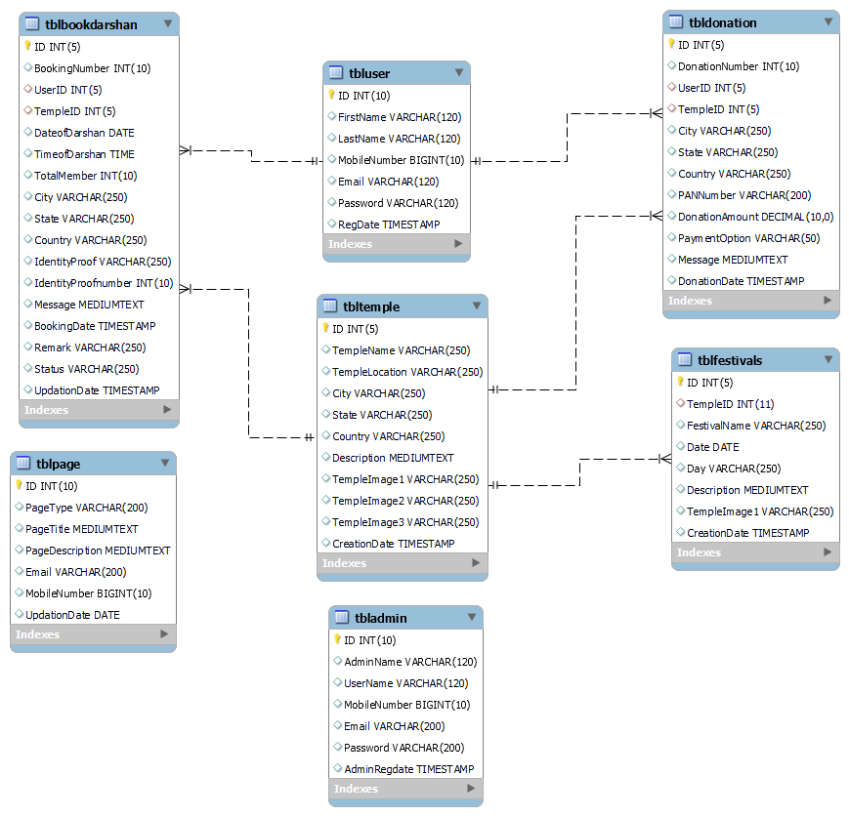

***Fig. 9 Class Diagram***

**System Testing**

**SOFTWARE TESTING TECHNIQUES:**

Software testing is a critical element of software quality assurance and represents the ultimate review of specification, designing and coding.

**OBJECTIVES:**

1. Testing is process of executing a program with the intent of finding an error.
2. A good test case design is one that has a probability of finding an as yet undiscovered error.
3. A successful test is one that uncovers an as yet undiscovered error.

These above objectives imply a dramatic change in view port.

Testing cannot show the absence of defects, it can only show that software errors are present.

There are three types of testing strategies

1. Unit test
2. Integration test

3. Performance test

**Unit Testing:**

Unit testing focuses verification efforts on the smallest unit of software design module. The unit test is always white box oriented. The tests that occur as part of unit testing are testing the module interface, examining the local data structures, testing the boundary conditions, execution all the independent paths and testing error-handling paths.

**Integration Testing:**

Integration testing is a systematic technique or construction the program structure while at the same time conducting tests to uncover errors associated with interfacing. Scope of testing summarizes the specific functional, performance, and internal design characteristics that are to be tested. It employs top-down testing and bottom-up testing methods for this case.

**Performance Testing:**

Timing for both read and update transactions should be gathered to determine whether system functions are being performed in an acceptable timeframe.

**Test Cases**

**Table 8: Test Cases**

|  |  |  |  |  |  |  |  |
| --- | --- | --- | --- | --- | --- | --- | --- |
| Test case ID | Test case Objective | Prerequisite | Steps | Input Data | Expected Output | Actual Output | Status |
| Tc_01 | Test case for register user | All fields in the form are mandatory to fill. | 1. Click on new_here? get involved. 2. Register yourself . 3. Register | first_name,last_name,email,mob.no.password,confirm password. | You successfully registered.!(profile is created) | You successfully registered.!(profile is created) | Pass |
| Tc_02 | Test case for Login user | Fill userID and password field. | 1. Click on new_here? get involved.  2.Login | UserId and password | Successfully login | Successfully login (in profile) | Pass |
| Tc_03 | Test case for donation | Fill the mandatory fields. | 1. register/ login yourself 2. Temples 3. Donation 4. Fill details 5. send | City,state,country,pan No., donation amt, payment option. | Thank you for donation and shows donation id. And in donation history download the receipt. | Thank you for donation and sh donation id”xxxxxx”.And in donation history download the receipt. | Pass |
| Tc_04 | Test case for darshan booking | Fill the mandatory fields. | 1.register/ login yourself  2.Temples  3.Darshan booking  4.Fill details  5.send | Date_of_darshan,time,total members,city,state,country,id proof. | Thank you for booking darshan.show the darshan receipt no. | Thank you for booking darshan. the darshan receipt no.”xxxxxxx”. | Pass |
| Tc_05 | Test case for admin | Admin login is required. | 1. Admin   2.login | Userid and password | Show the administration panel | Shows the administration panel | Pass |

**Output Screens of Project**

**Home Page**

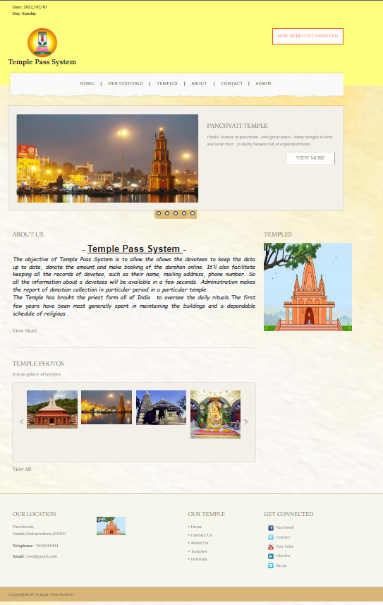

**Test case - 01 and 02:**

**Registration/Login Page**

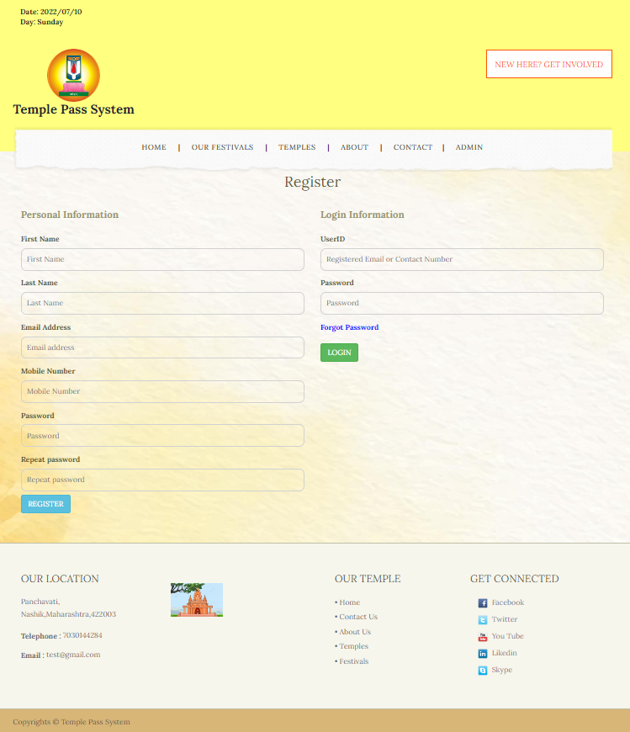

**Forgot Password**

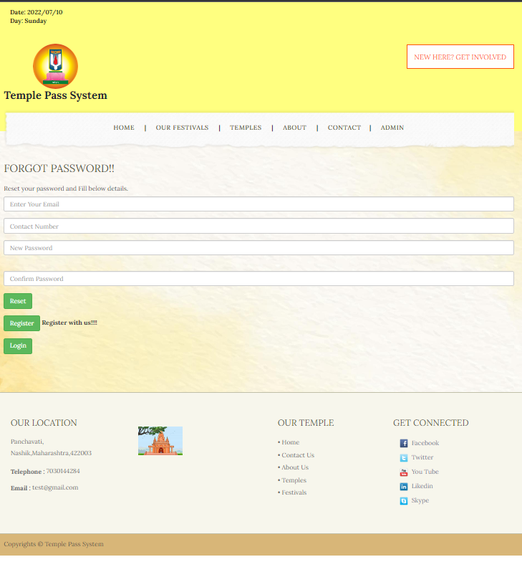

**FESTIVALS:**

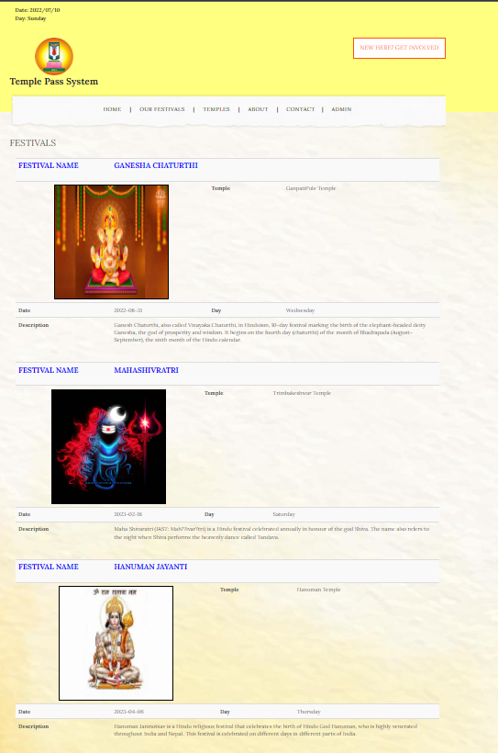

**Temples**

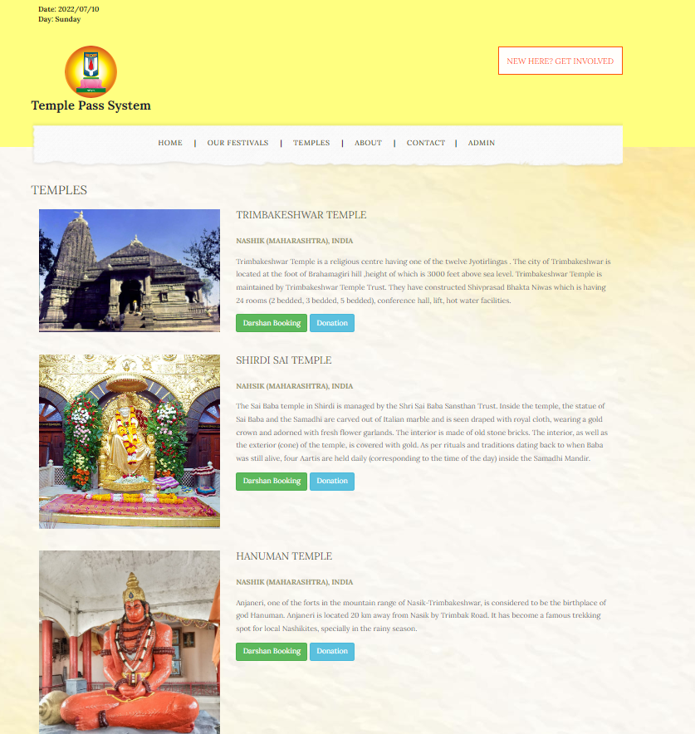

**Test Case - 04:**

**Darshan Booking**

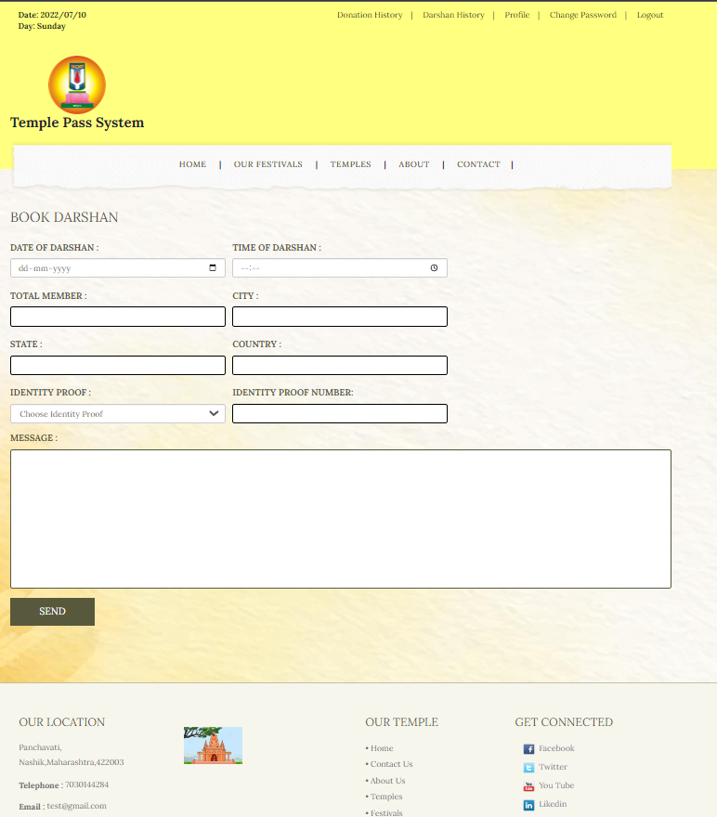

**Thank You Page**

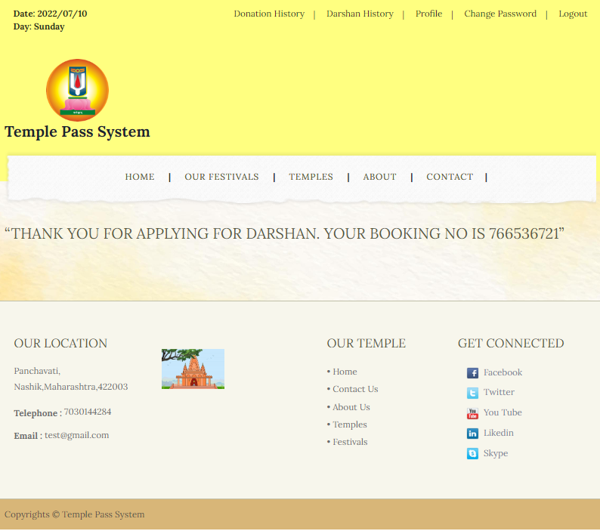

**Test case - 03:**

**Donation**

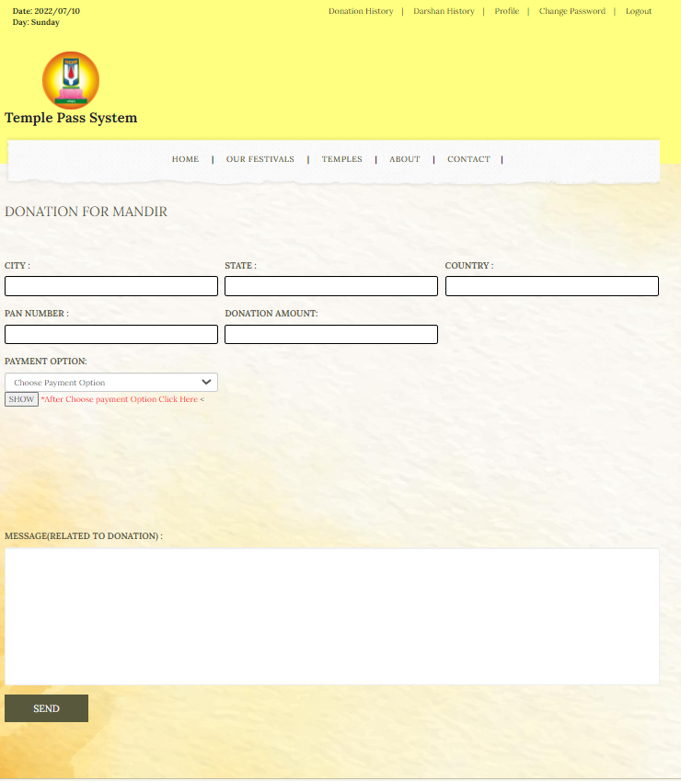

**Thank You Page**

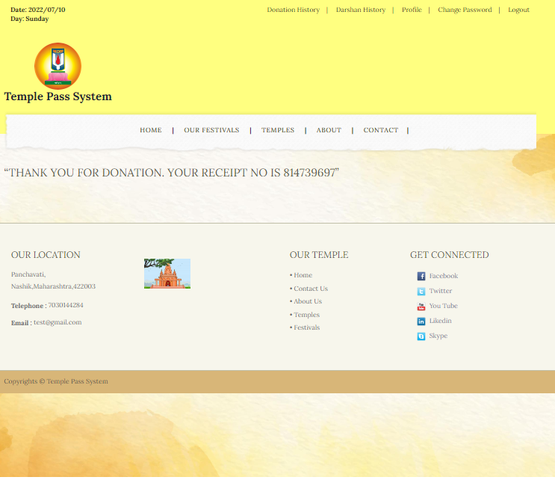

**About Us**

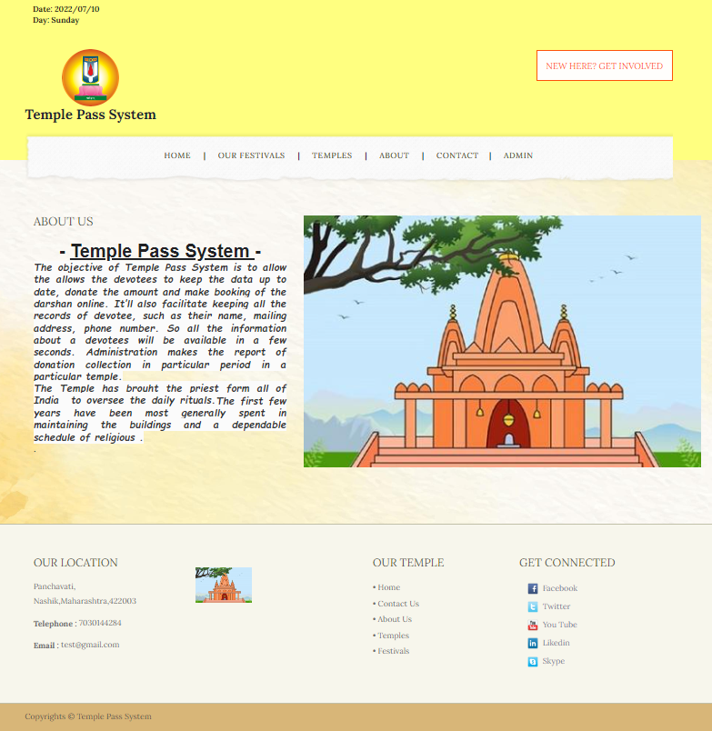

**Contact us**

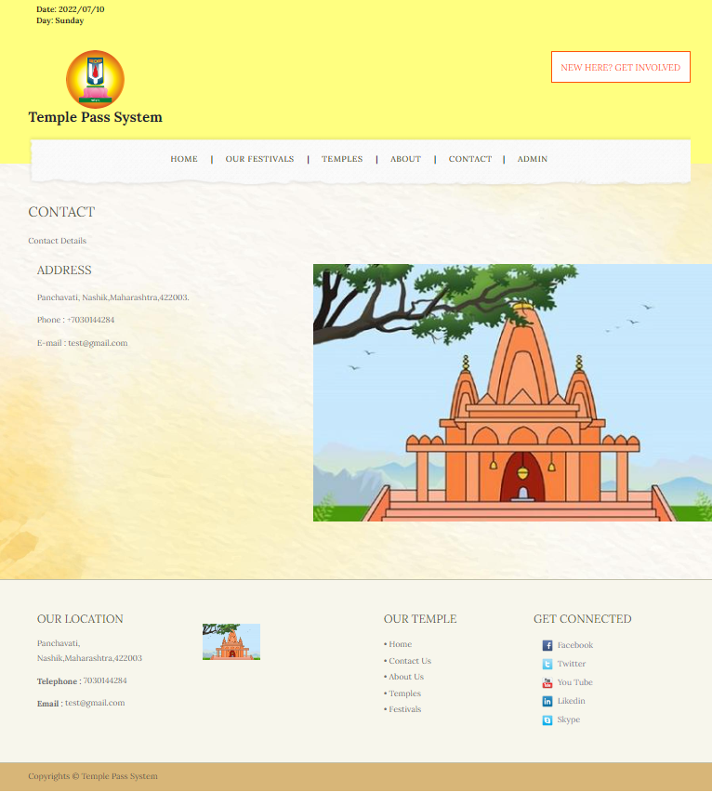

**Donation History**

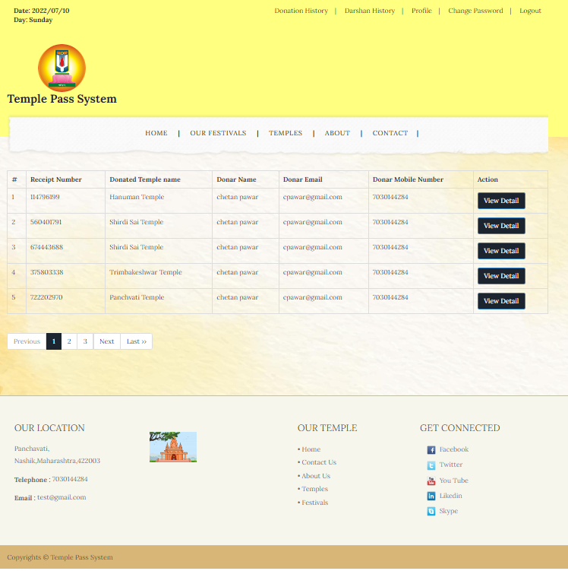

**Test case - 03:**

**View Detail of Donation**

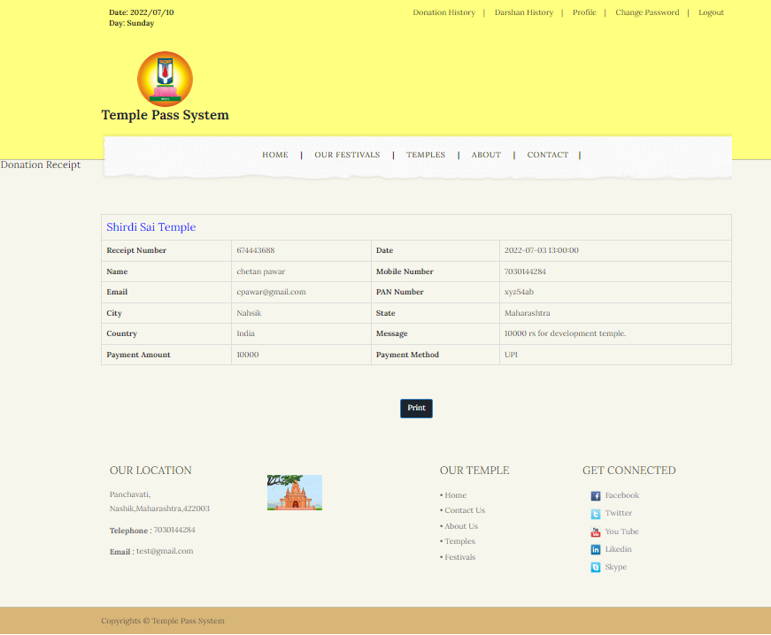

**Test case - 04:**

**Darshan History**

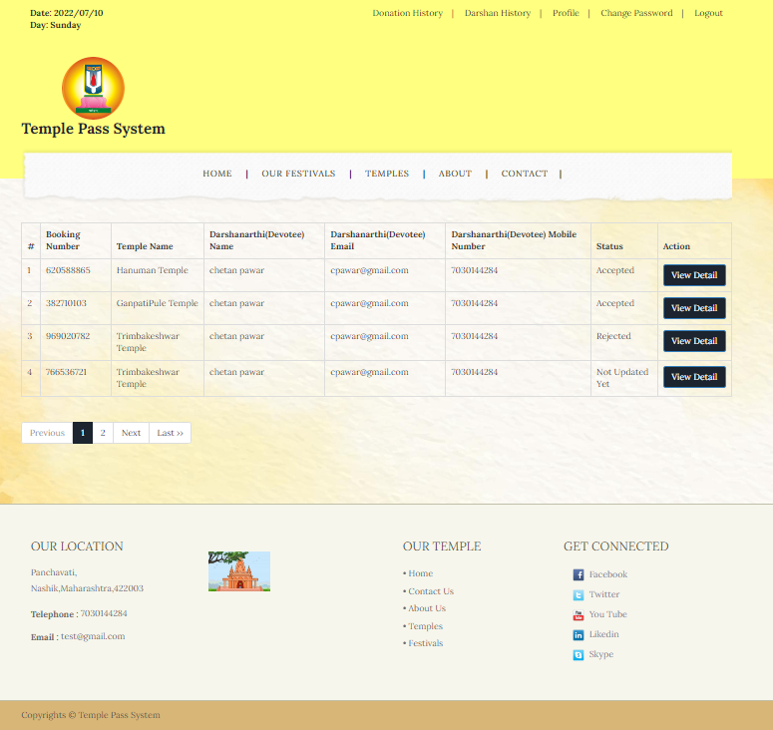

**View Booking Details**

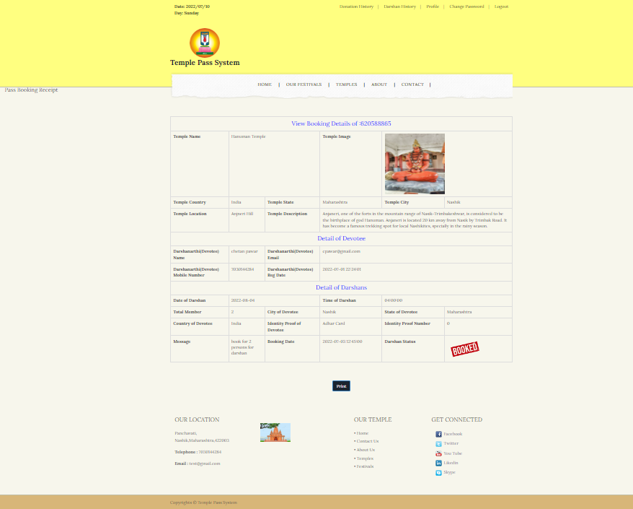

**Profile**

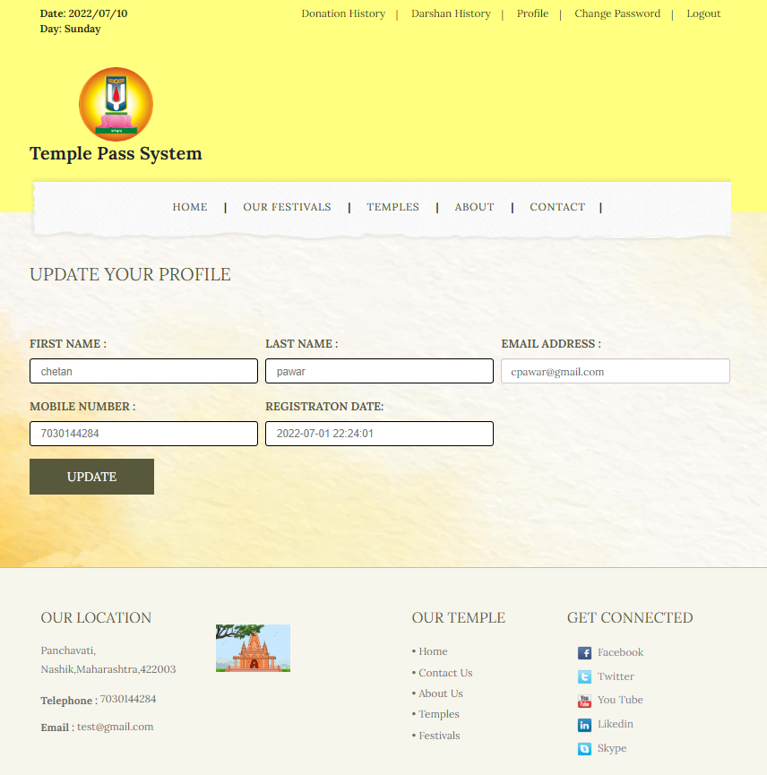

**Change Password**

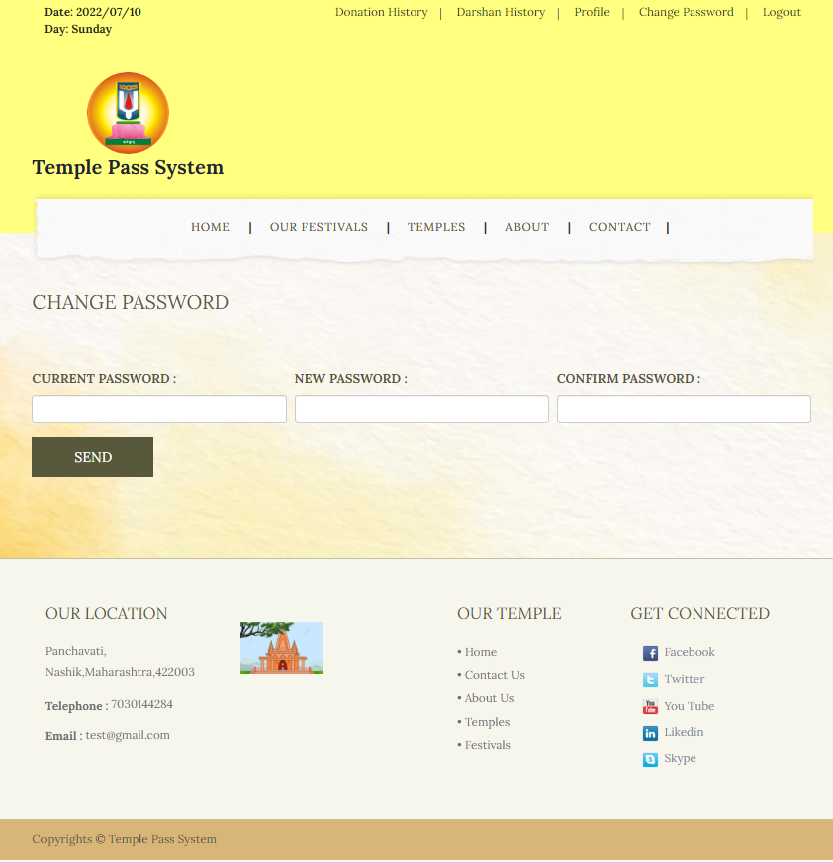

**Test case - 05:**

**Admin Login**

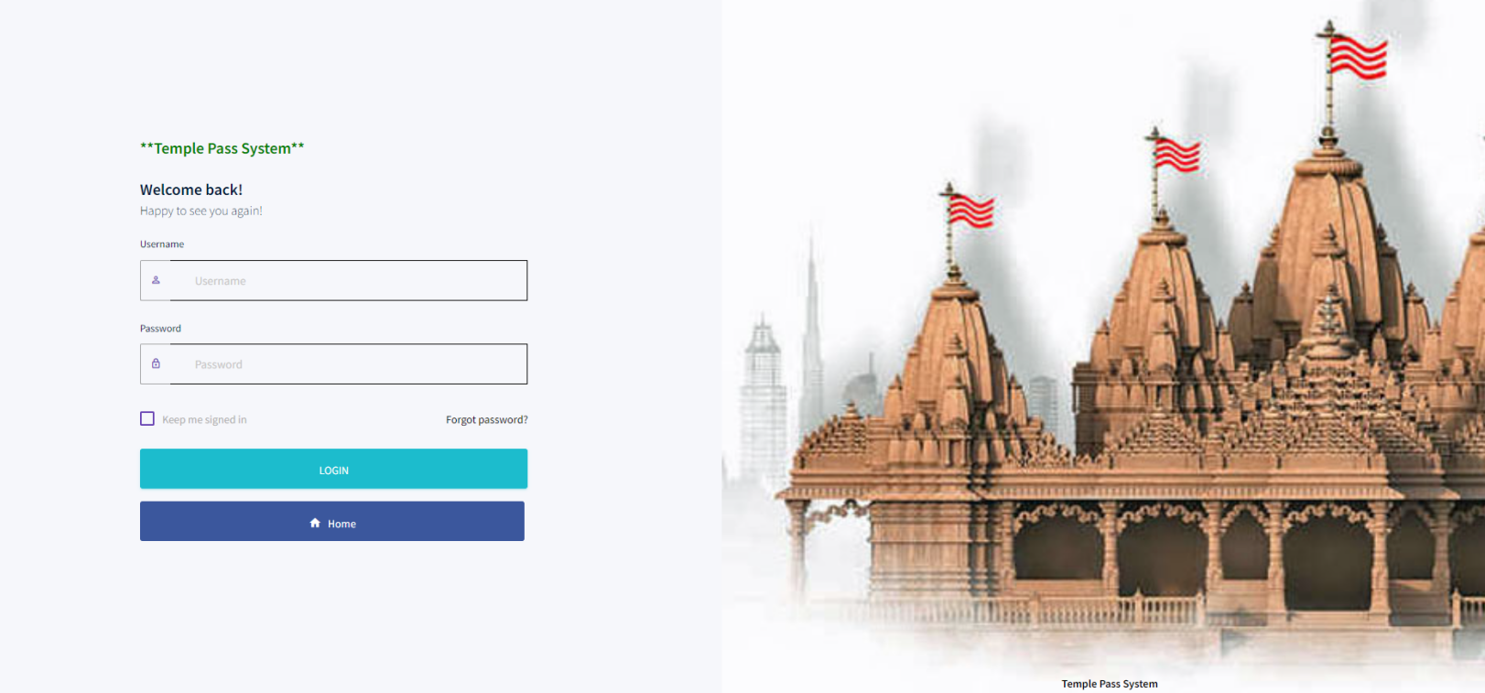

**Forgot Password**

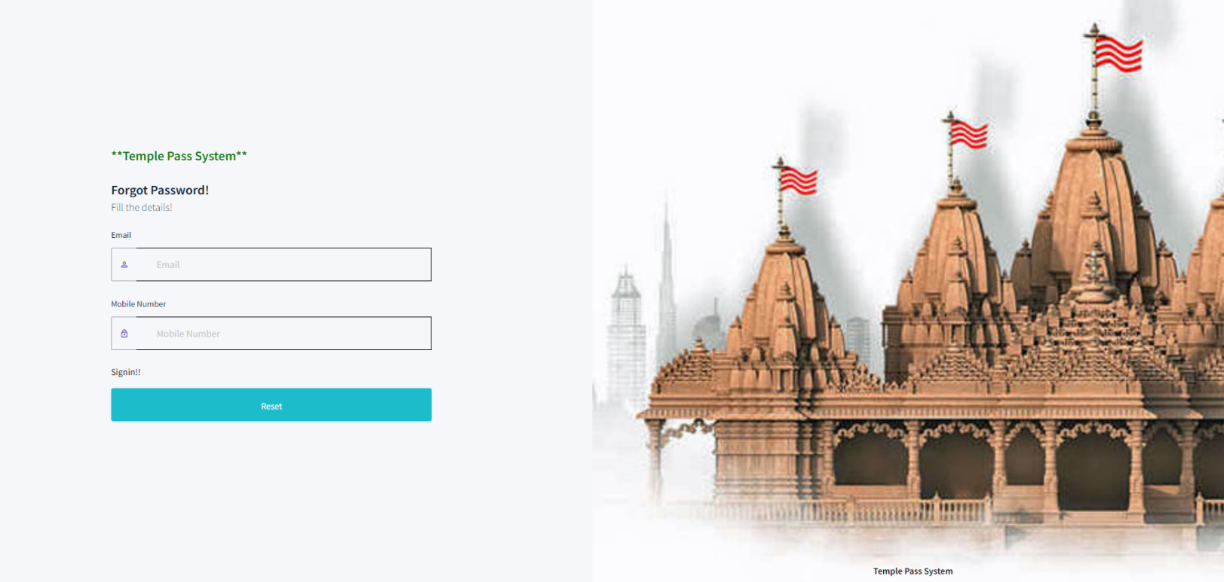

**Reset Password**

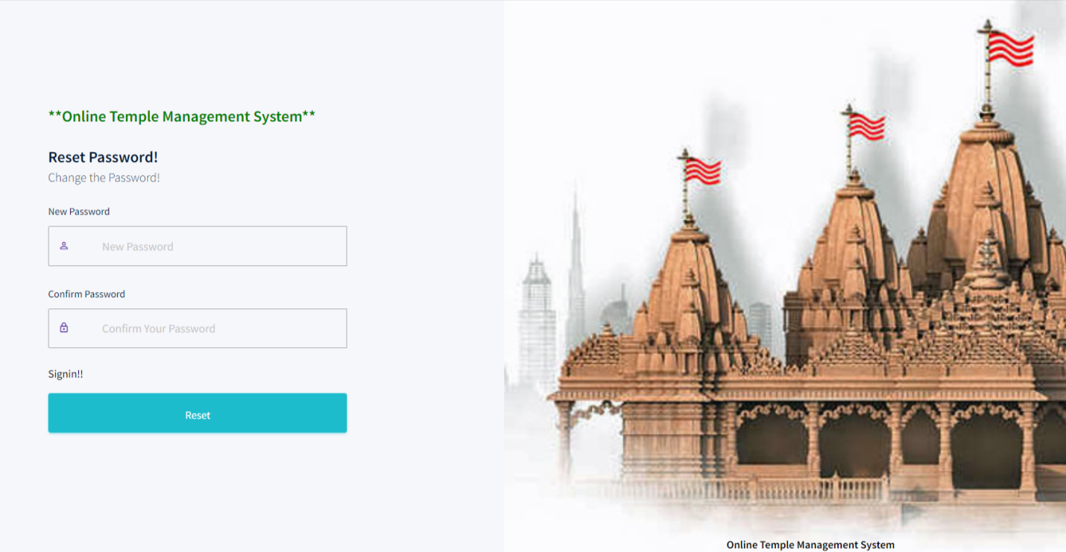

**Dashboard**

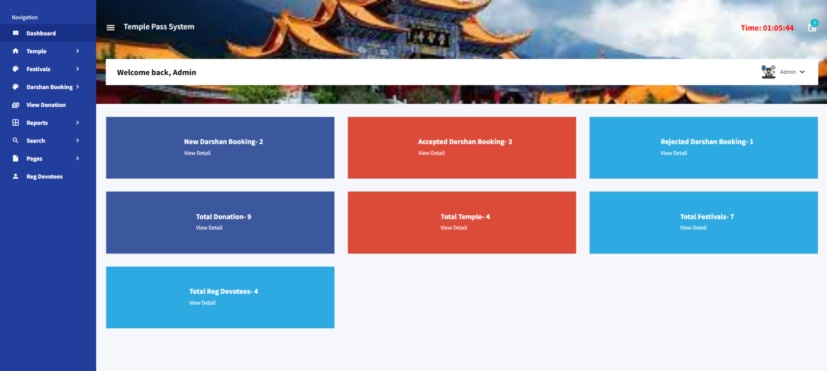

**Profile**

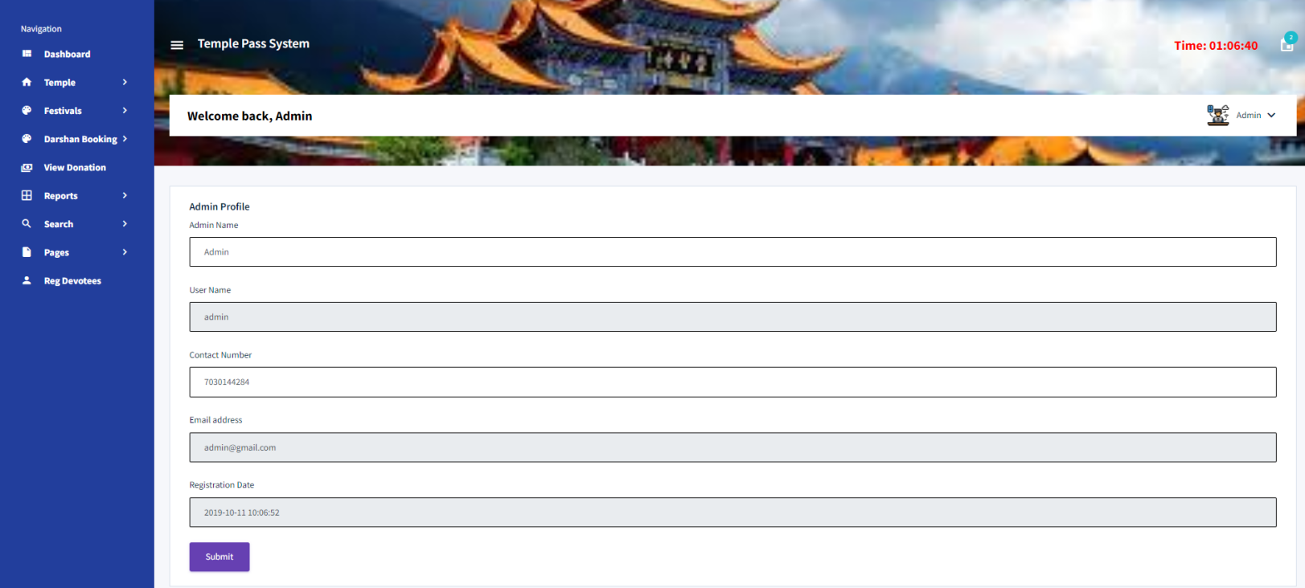

**Change Password**

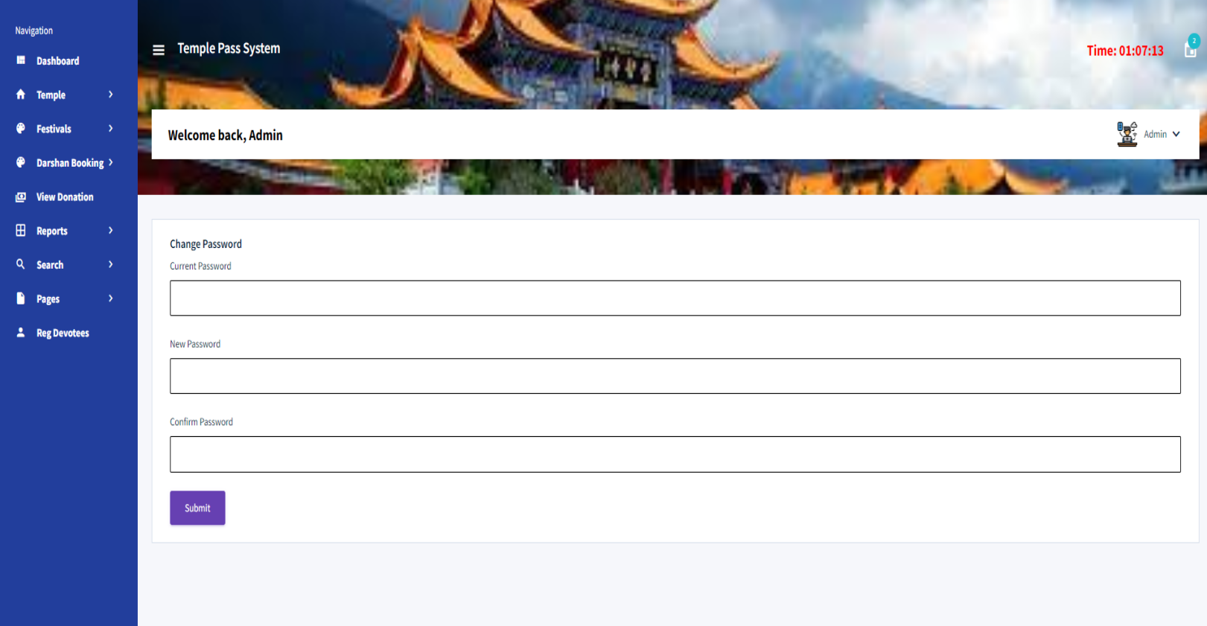

**Add Temple**

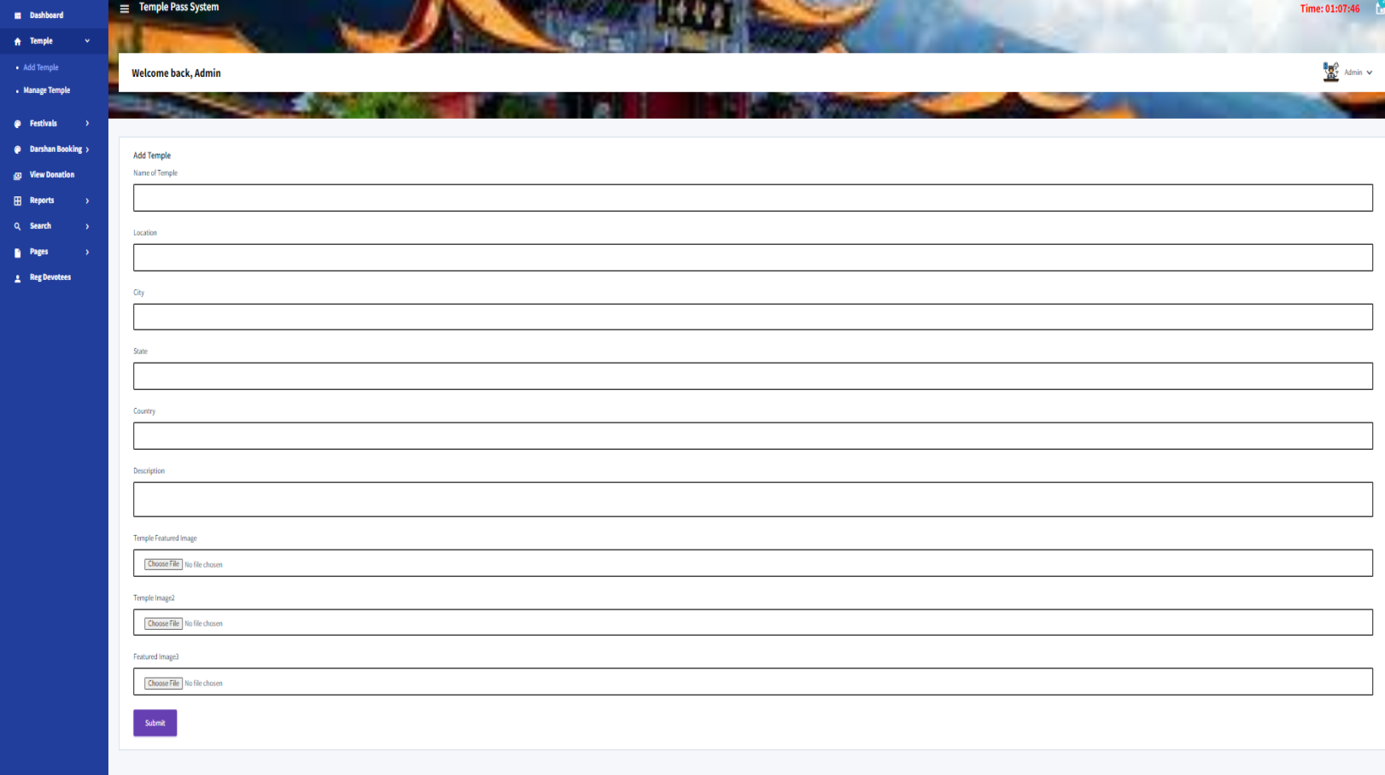

**Manage Temple**

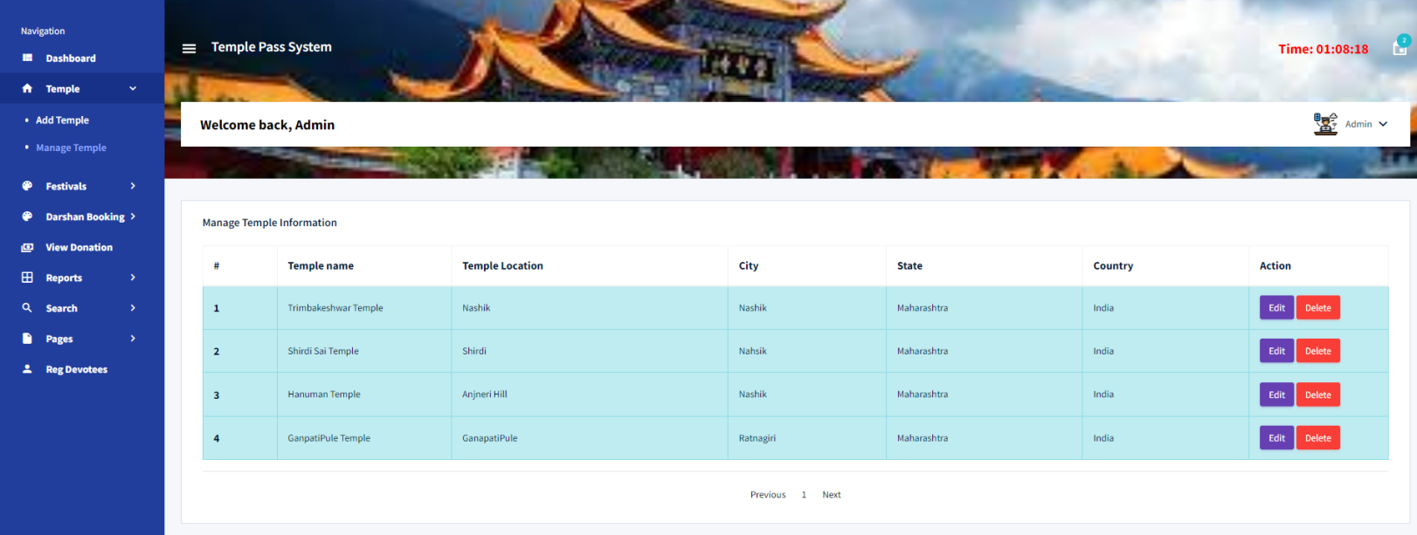

**Update Temple**

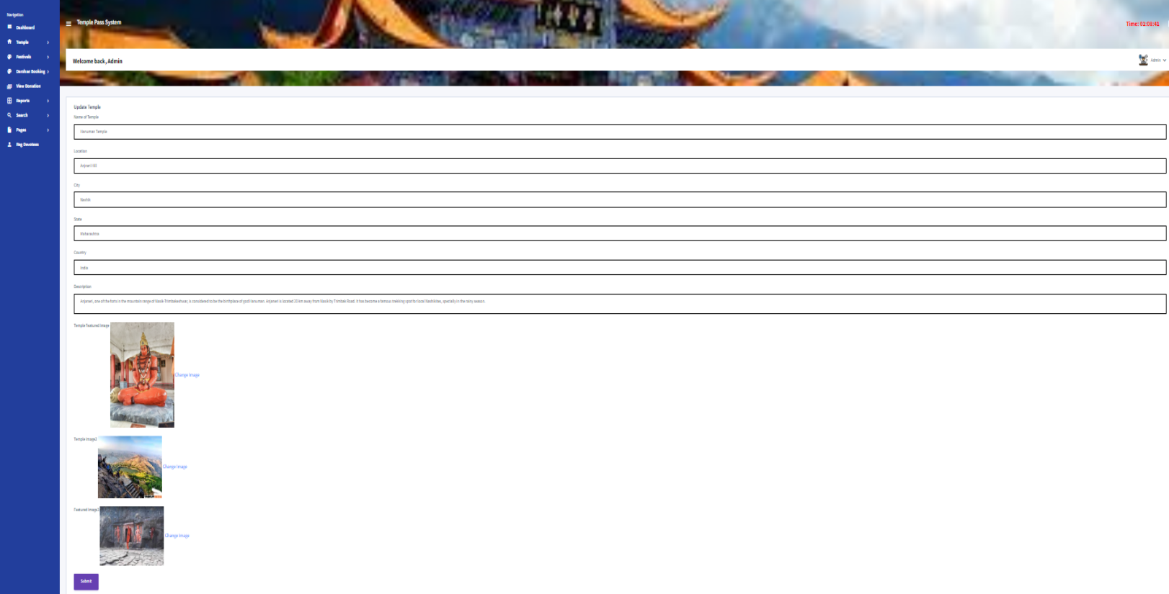

**Add Festivals**

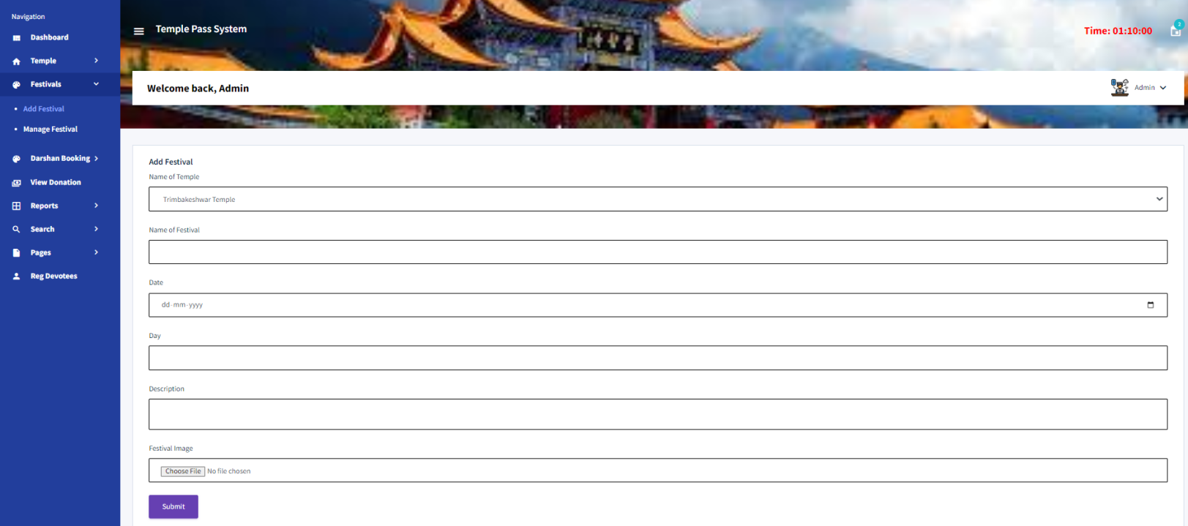

**Manage Festivals**

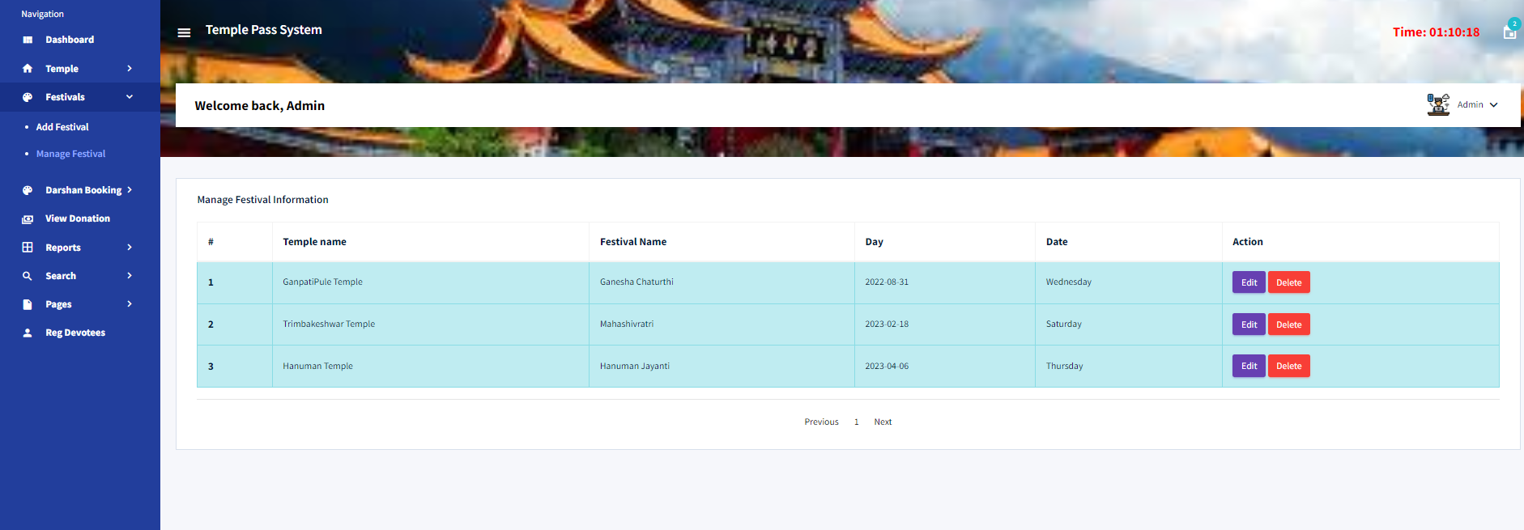

**Update Festivals**

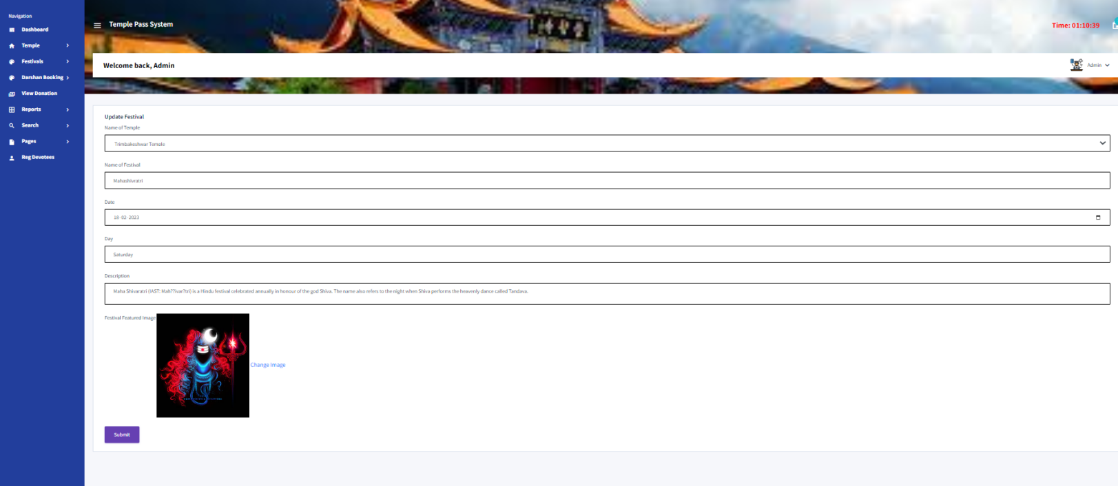

**New Darshan Booking**

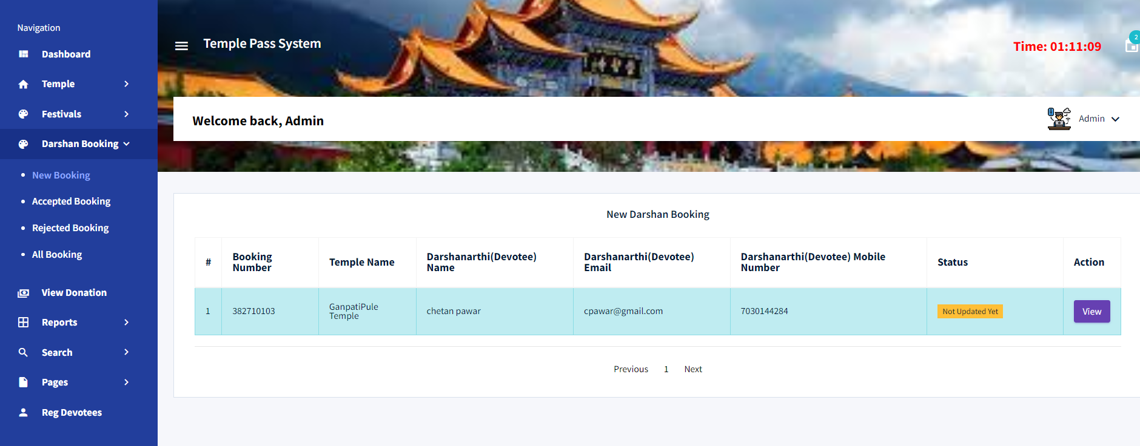

**View Detail of new Booking**

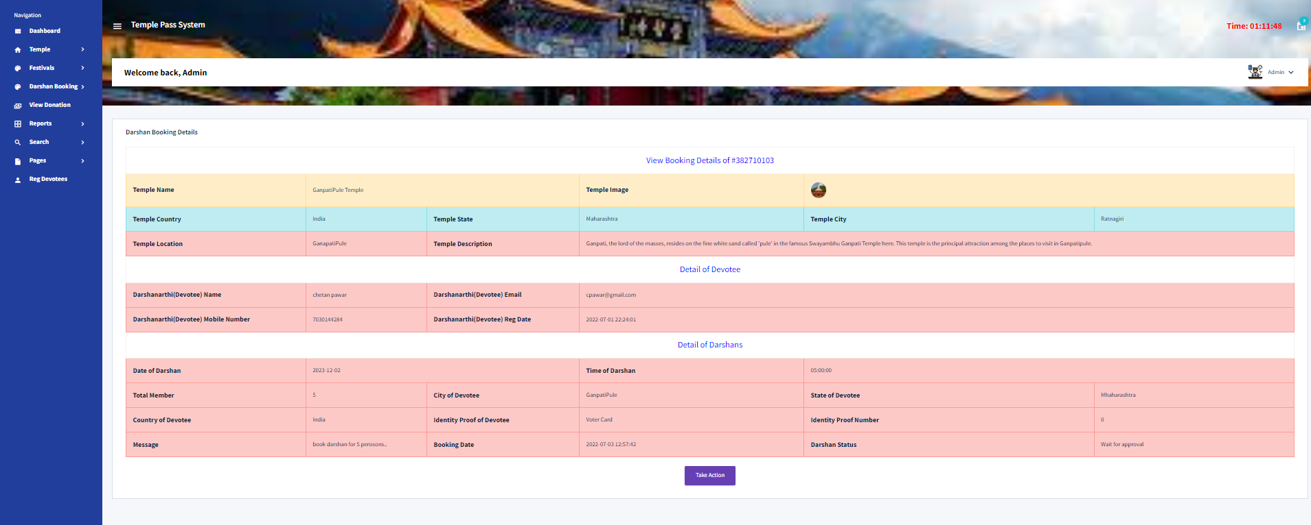

**Accepted Booking**

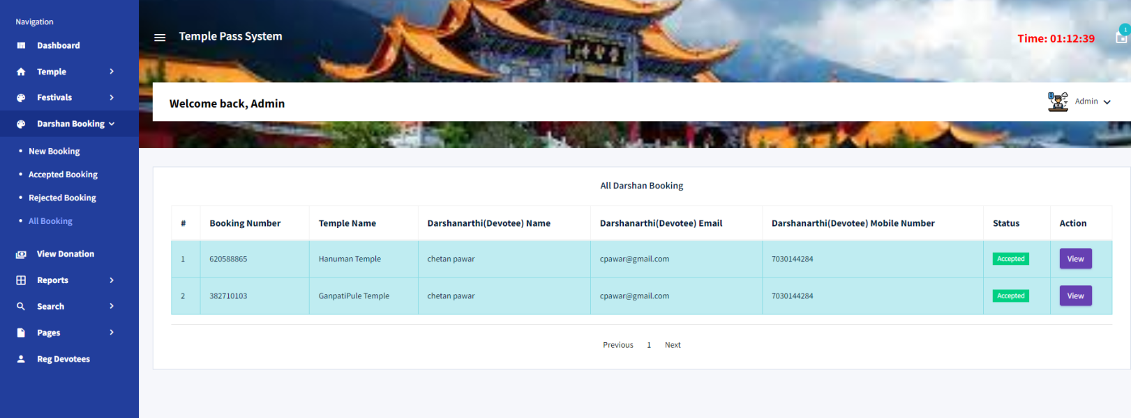

**View Accepted Booking**

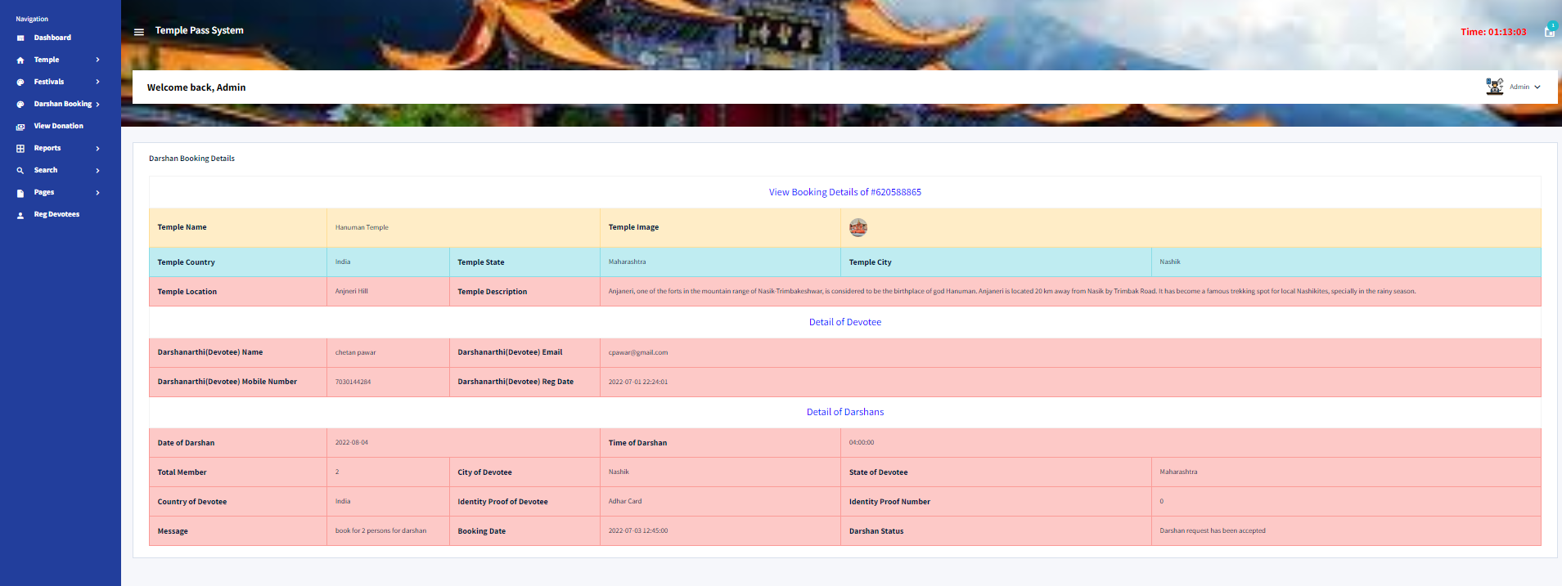

**Donation**

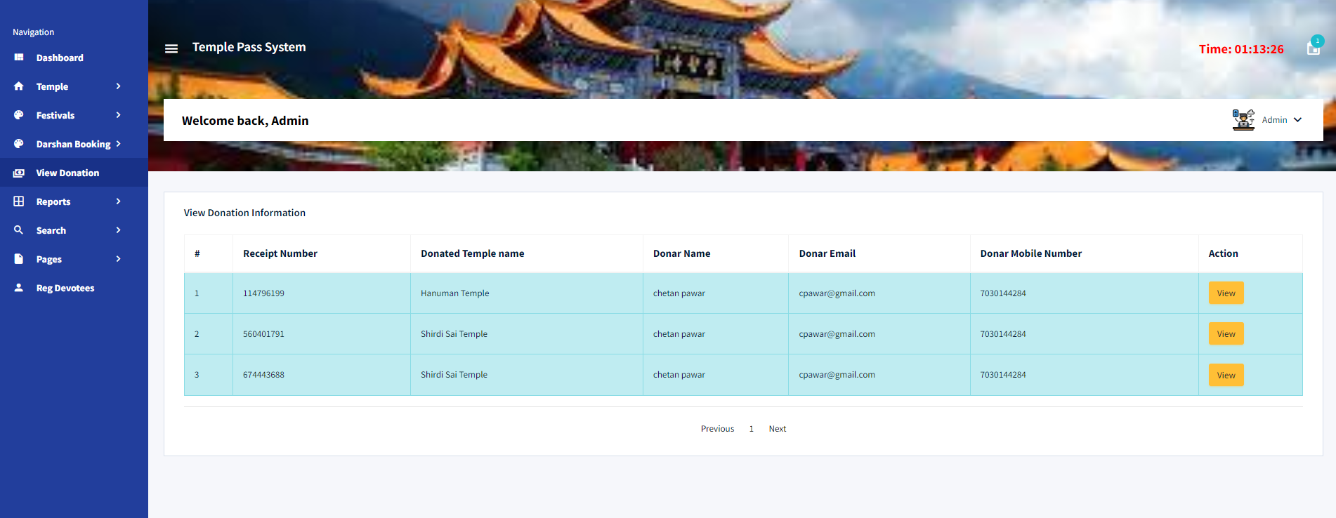

**View Donation Detail**

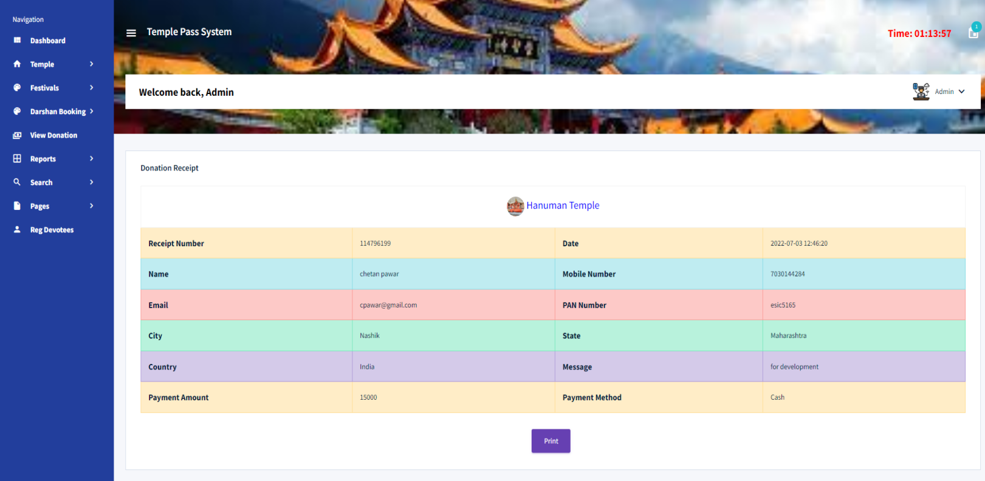

**Darshan Booking Report**

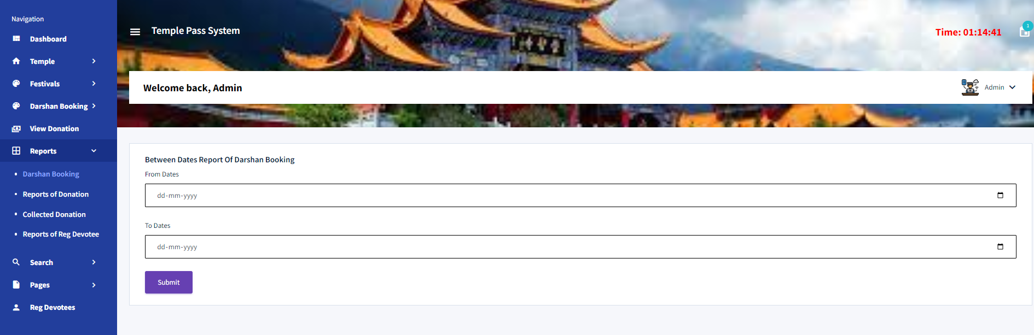

**View Detail of Booking Report**

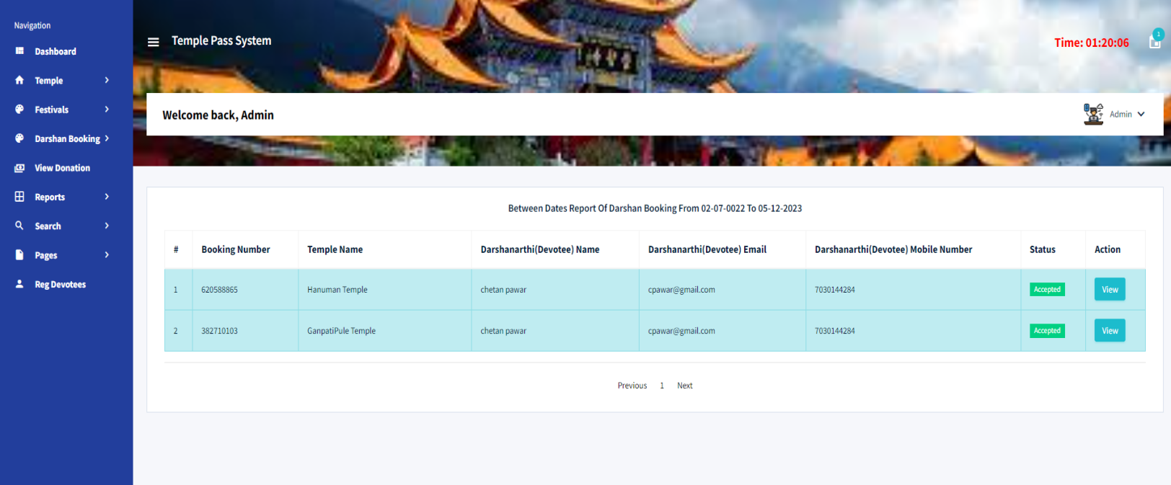

**Report of Donation**

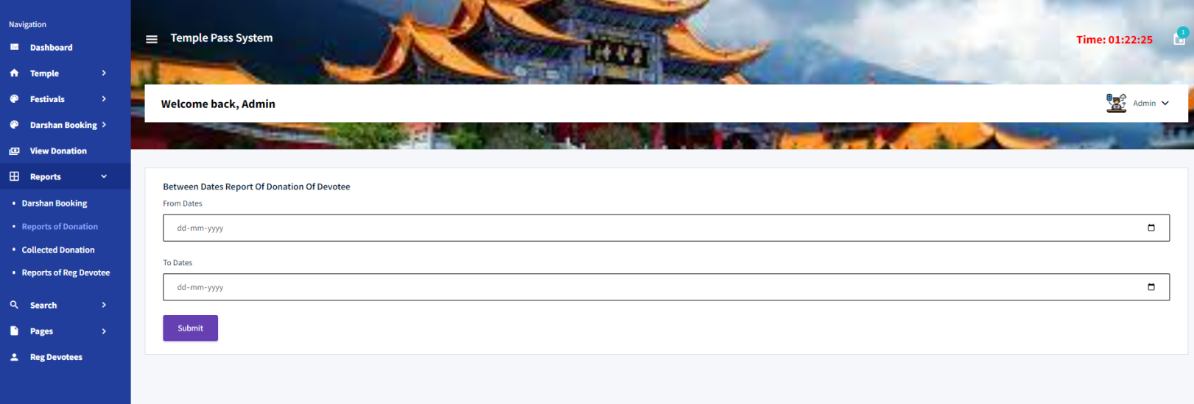

**View detail of report of donation**

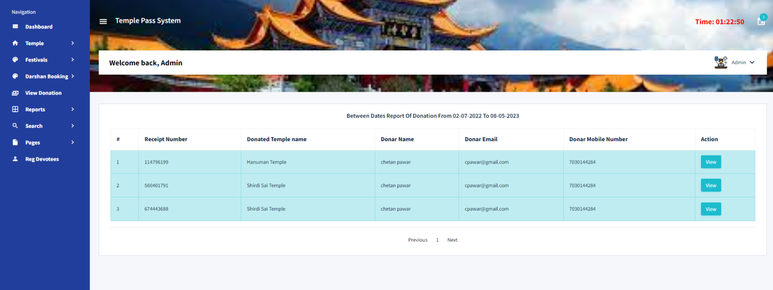

**Report of Collected Donation**

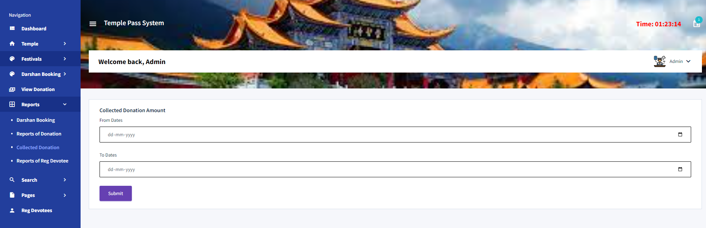

**View Collected Amount**

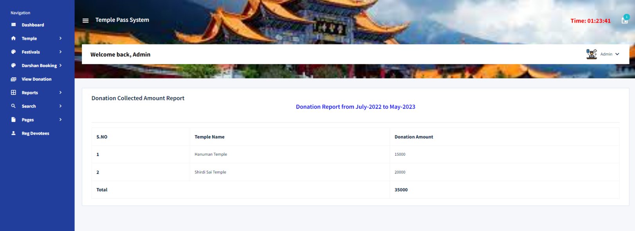

**Report of Registered Devotees**

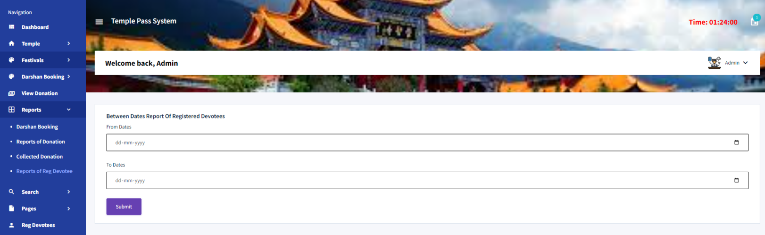

**View Details of Registered Devotees**

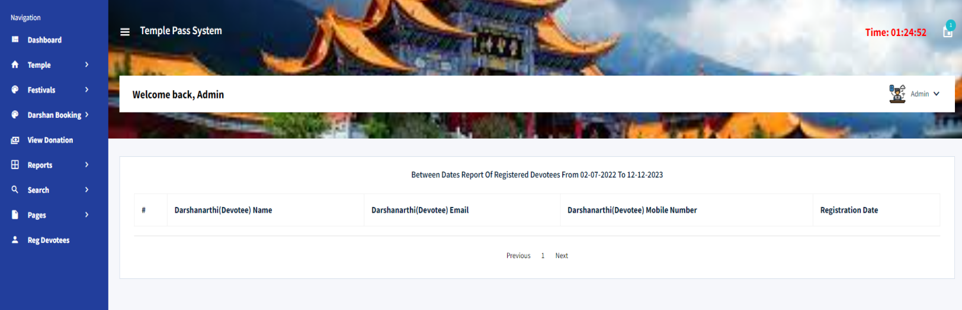

**Search Darshan Booking**

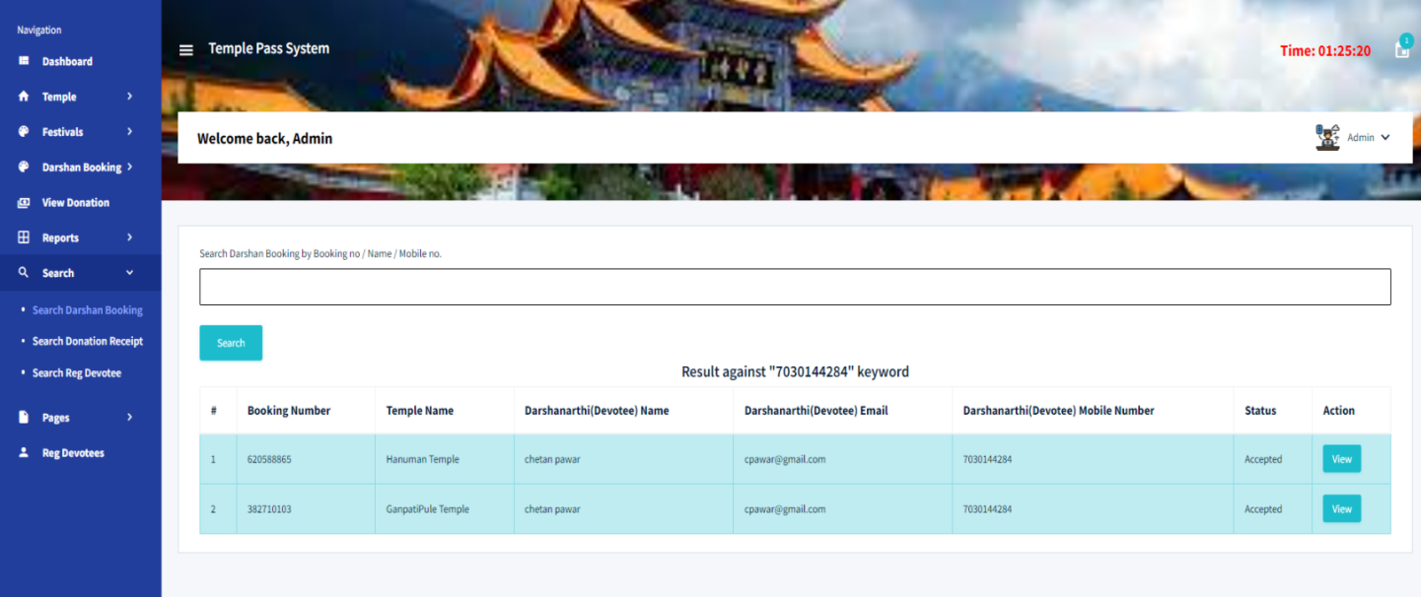

**Search Donation Receipt**

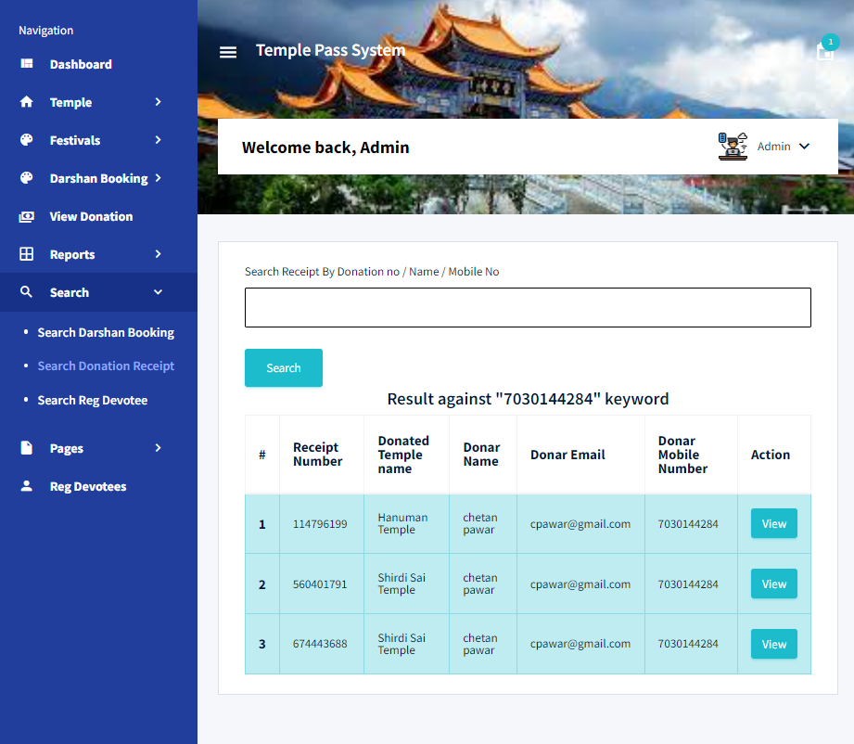

**Search Devotees**

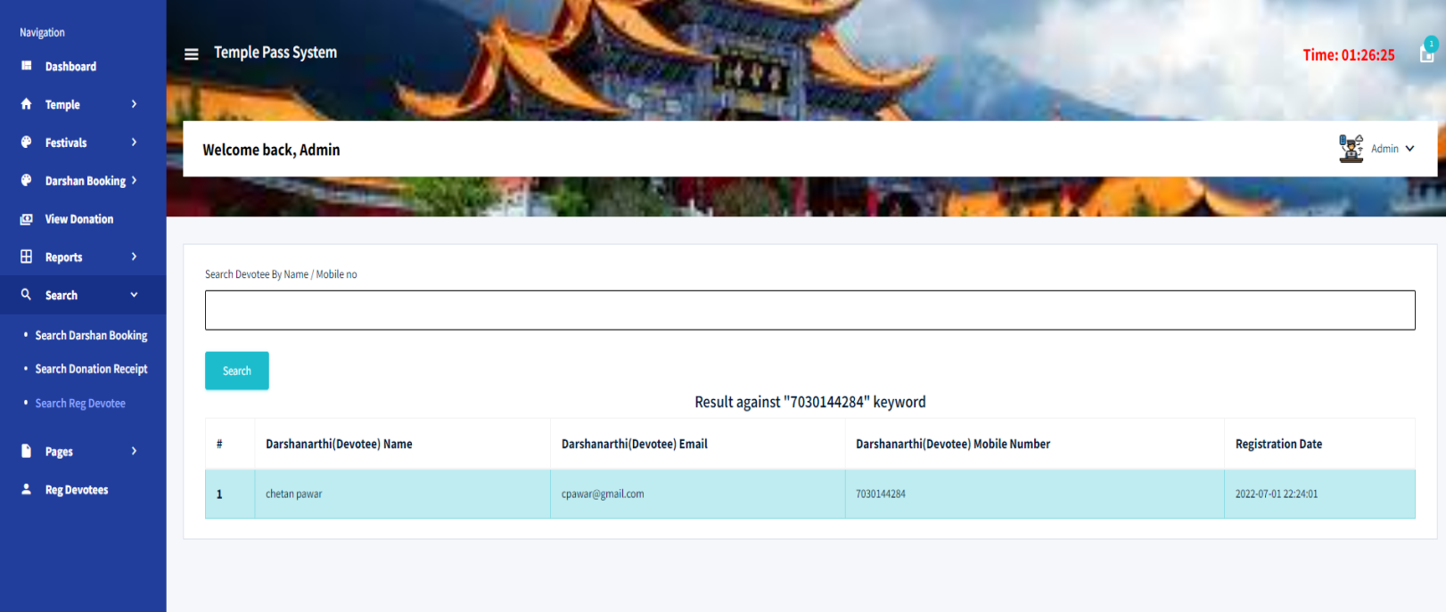

**About Us Page**

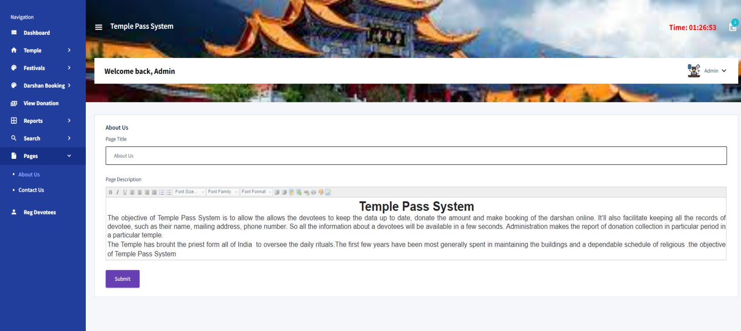

**Contact Us Page**

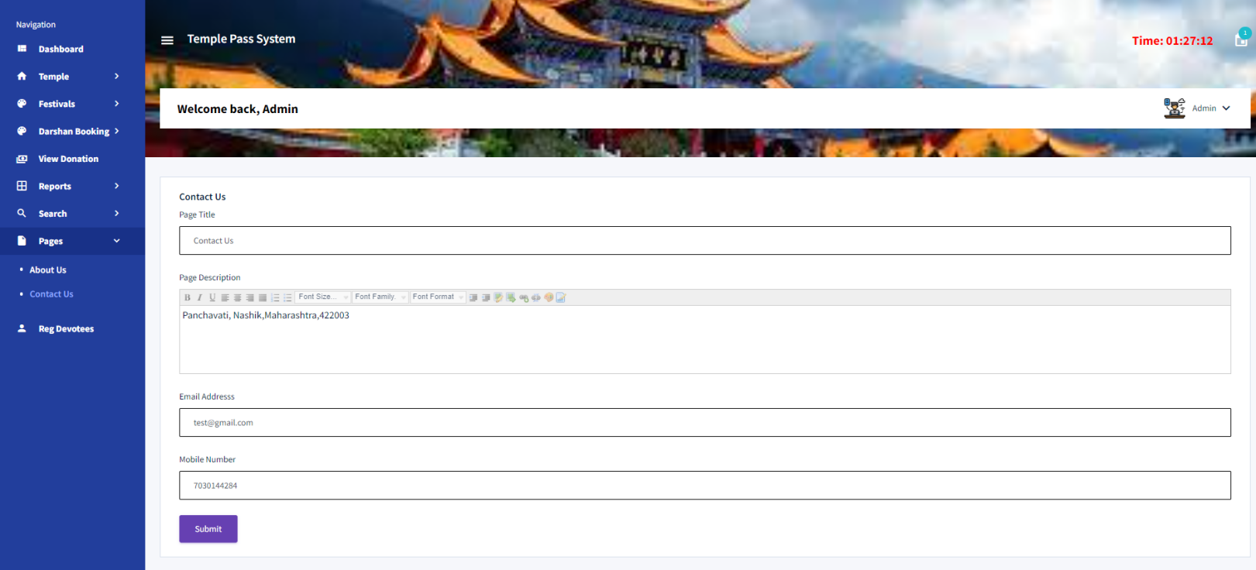

**View Registered Devotees**

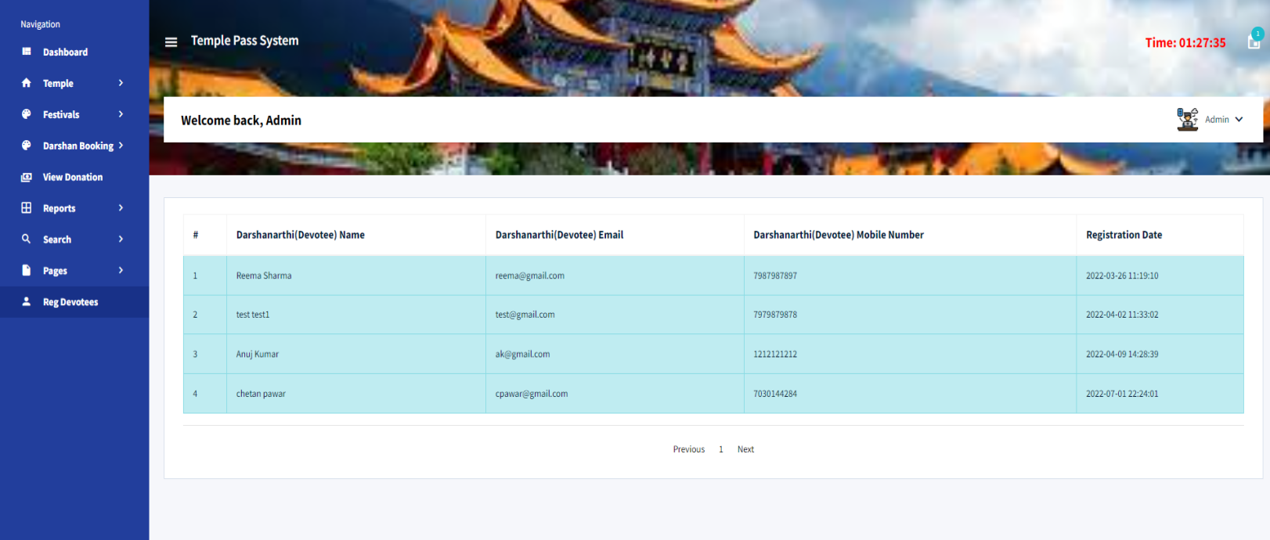

**Conclusion**

The project titled as **Temple Pass System** was deeply studied and analyzed to design the code and implement. It was done under the guidance of the experienced project guide. All the current requirements and possibilities have been taken care during the project time.

**Temple Pass System** can be used by temple administration to maintain the records of devotees, donation and darshan booking easily. Achieving this objective is difficult using a manual system as the information is scattered, can be redundant and collecting relevant information may be very time consuming. All these problems are solved using this project

**Bibliography**

**For PHP**

* Programming PHP - Rasmus Lerdorf and Kevin Tatroe, O'Reilly publication
* Beginning PHP 5 - Wrox publication
* <https://www.w3schools.com/php/default.asp>
* https://www.php.net

**For JavaScript**

* HTML and JavaScript – Ivan Bayross
* https://www.programiz.com/javascript

**For MySQL**

* https://www.mysql.com
* [http://www.mysqltutorial.org](http://www.mysqltutorial.org/)

**For XAMPP**

* https://www.apachefriends.org

**Acknowledgment**

I am grateful to my entire faculties who have contributed in inspiring and clarifying my thought over the years; Prof. M. E. Maniyar and many other faculty of K. K. Wagh Institute of Engineering College. Special gratitude I give to my respected head of the department of MCA Prof. V. C. Bagal, for allowing me to use the facilities available and also help me to coordinate my project. I am thankful well-wishers and my family for spiritual, moral and even financial support. Thanks also to the entire staff of my College, Furthermore; I would also like to acknowledge with much appreciation the crucial role of faculty members on this occasion. Last but not least, I would like to thank friends who help me to assemble the parts and gave a suggestion about the project. Finally, Honor and glory to the highest God for having enabled me successfully accomplishes.

**Date:** **Signature**

**Place: Nashik**

**Name of the student**